**Project 1 - Deploying a Multi-Tier Website using EC2**

**Description**:

Amazon Elastic Compute Cloud (Amazon EC2) provides scalable computing

capacity in the Amazon Web Services (AWS) cloud. Using Amazon EC2 eliminates

your need to invest in hardware up front so you can develop and deploy applications

faster. You can use Amazon EC2 to launch as many or as few virtual servers as you

need, configure security and networking, and manage storage. Amazon EC2 enables

you to scale up or down to handle changes in requirements or spikes in popularity,

reducing your need to forecast traffic.

**Problem Statement:**

**Company ABC wants to move their product to AWS. They have the following**

**things set up right now:**

**1. MySQL DB**

**2. Website (PHP) The company wants high availability on this product, therefore**

**wants Auto Scaling to be enabled on this website.**

Hints:

*a. Database name: intel*

*b. Table name: data*

*c. Database password: intel123*

*d. Change hostname in website*

*e. Allow traffic from EC2 to RDS instance*

*f. Allow all-traffic to EC2 instance*

**Solution:**

To start with, lets create an **EC2 Instance** and configure an **Apache** web server on

top of the instance.

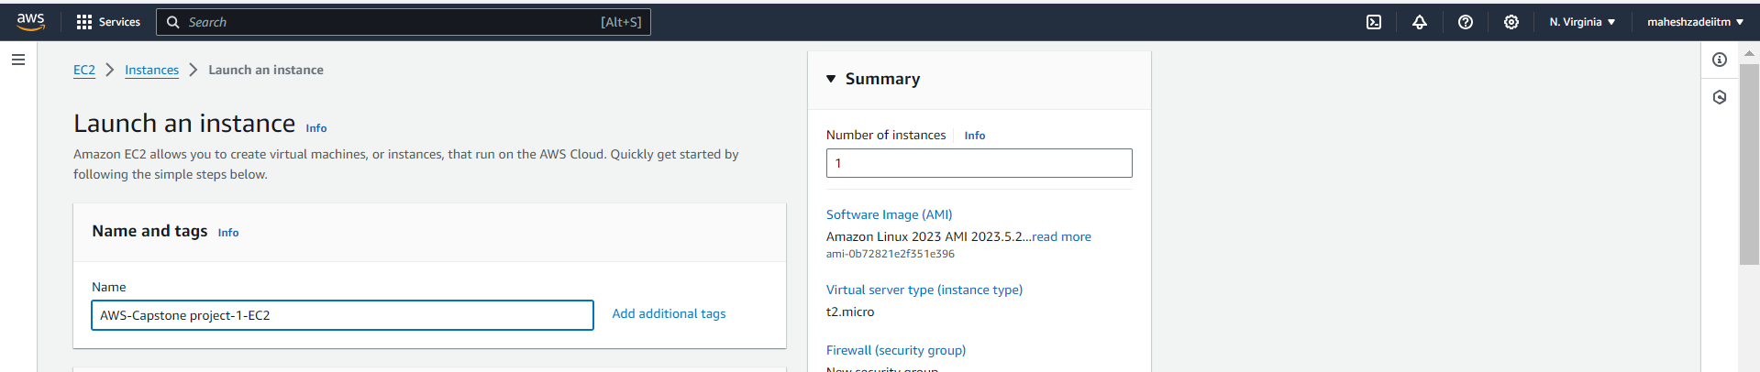

Make sure to select the **Ubuntu 22.04 AMI**. As we are going to use dependencies

which are supported for this AMI only.

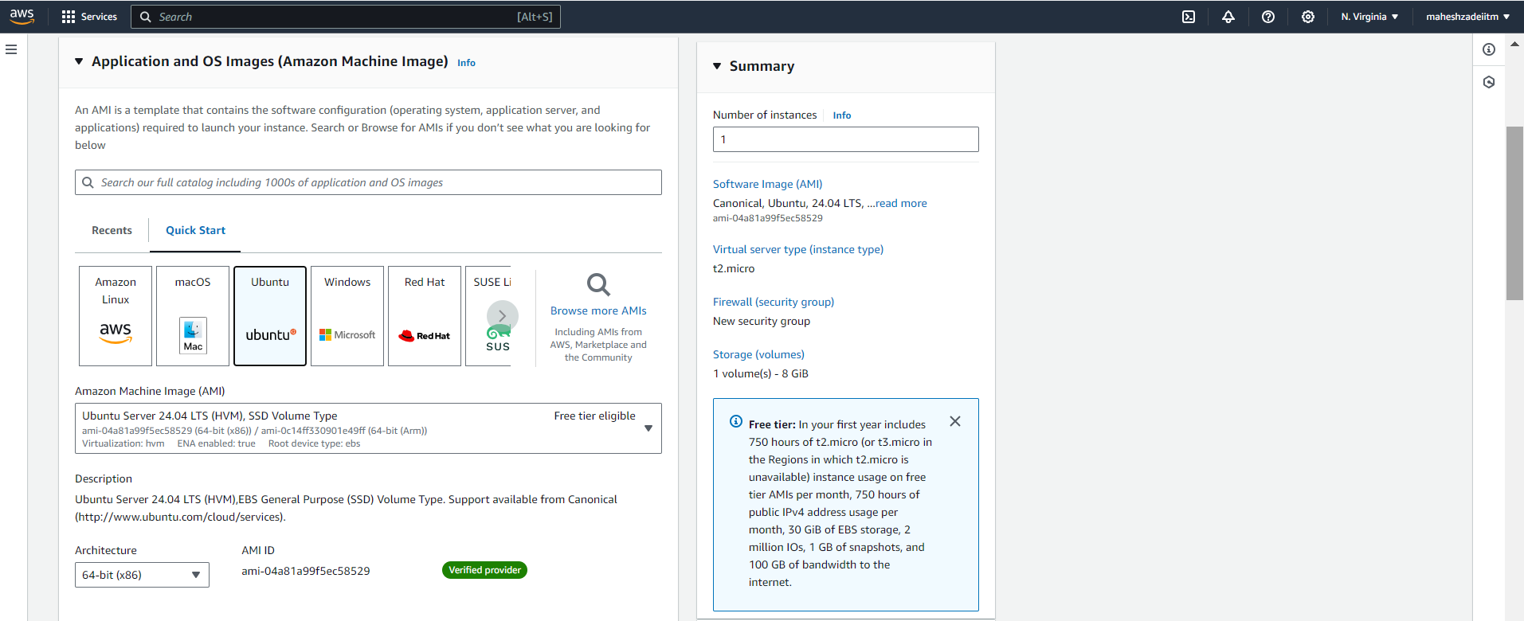

Choose **t2.micro** as **Instance Type**.

Select one of the existing key pairs or create a new one based on your preference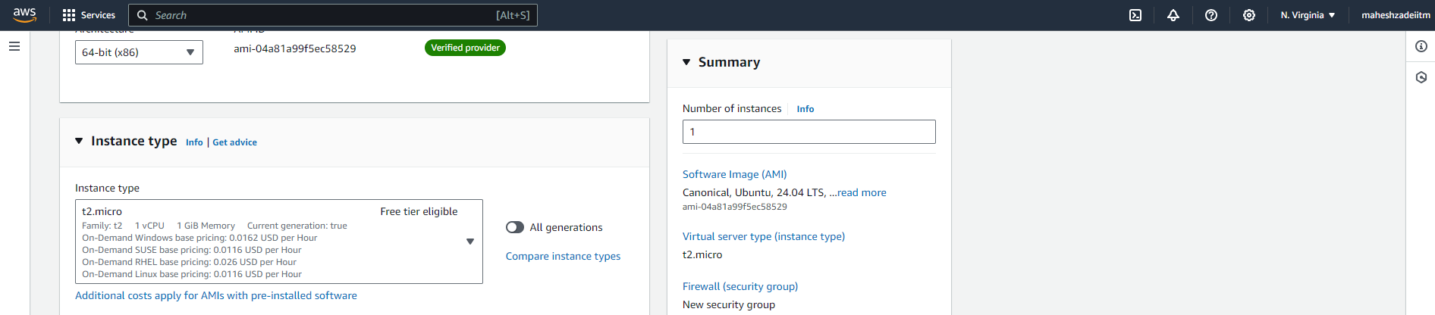

**Download key pair**

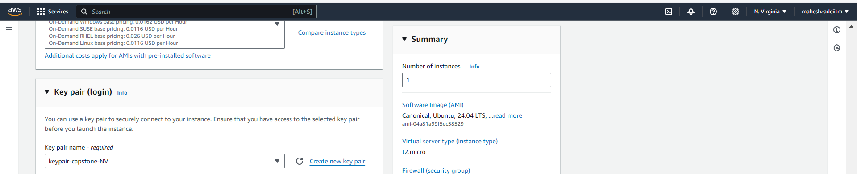

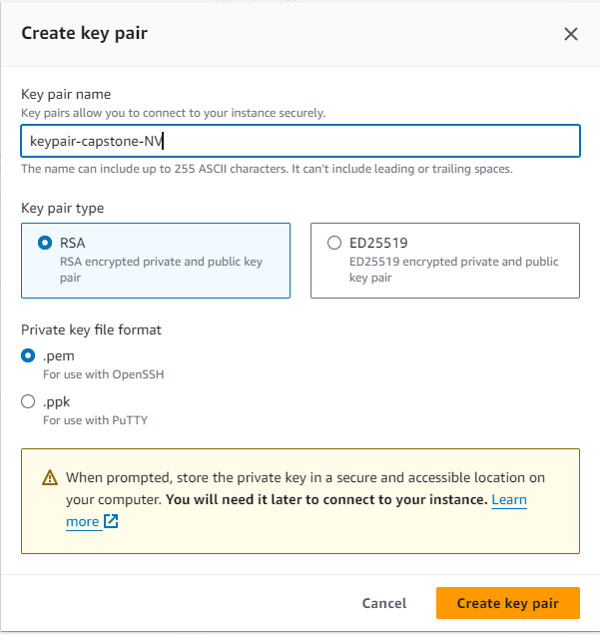

Now, In **Network Settings**, Click on **Edit**. Here we will configure rules for our EC2

Server.

Rules will allow **SSH** & **HTTP** Inbound Traffic from Source **0.0.0.0/0**.

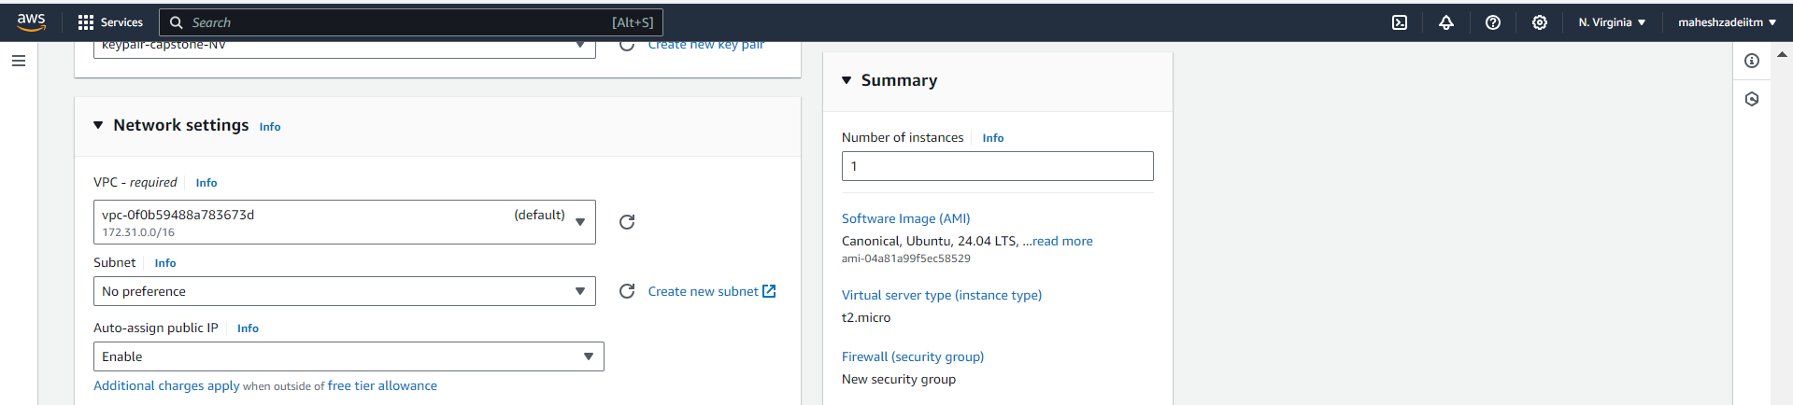

Provide a name to the security group such as **Capstone Project1-EC2-SG** in this case.

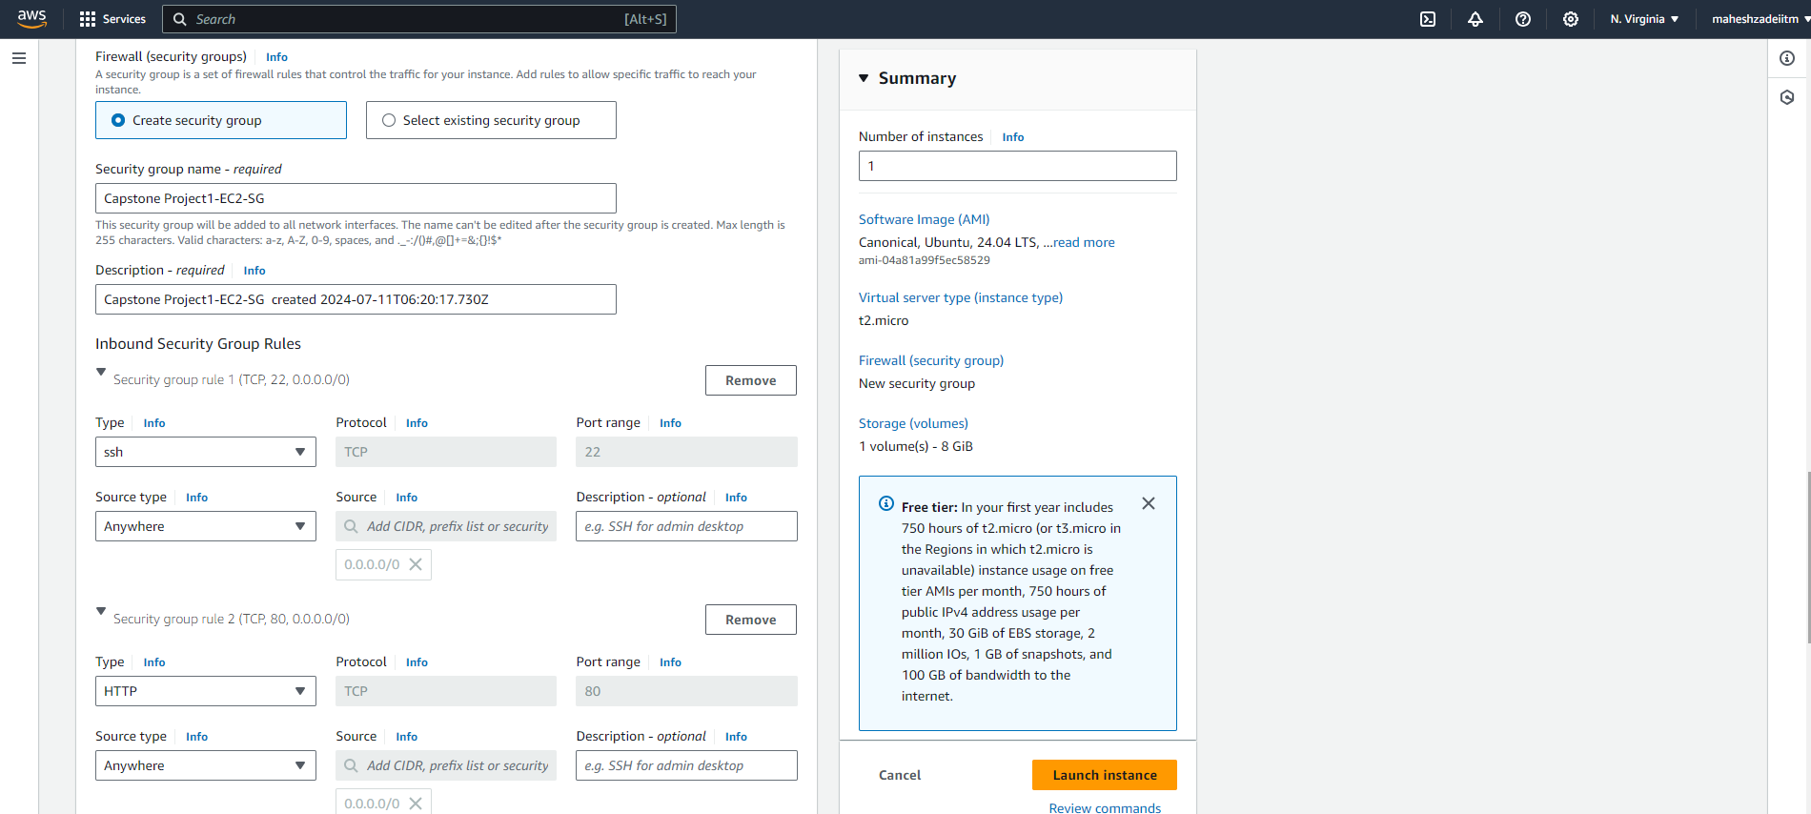

Select the default **8GiB gp2** root volume and launch the instance.

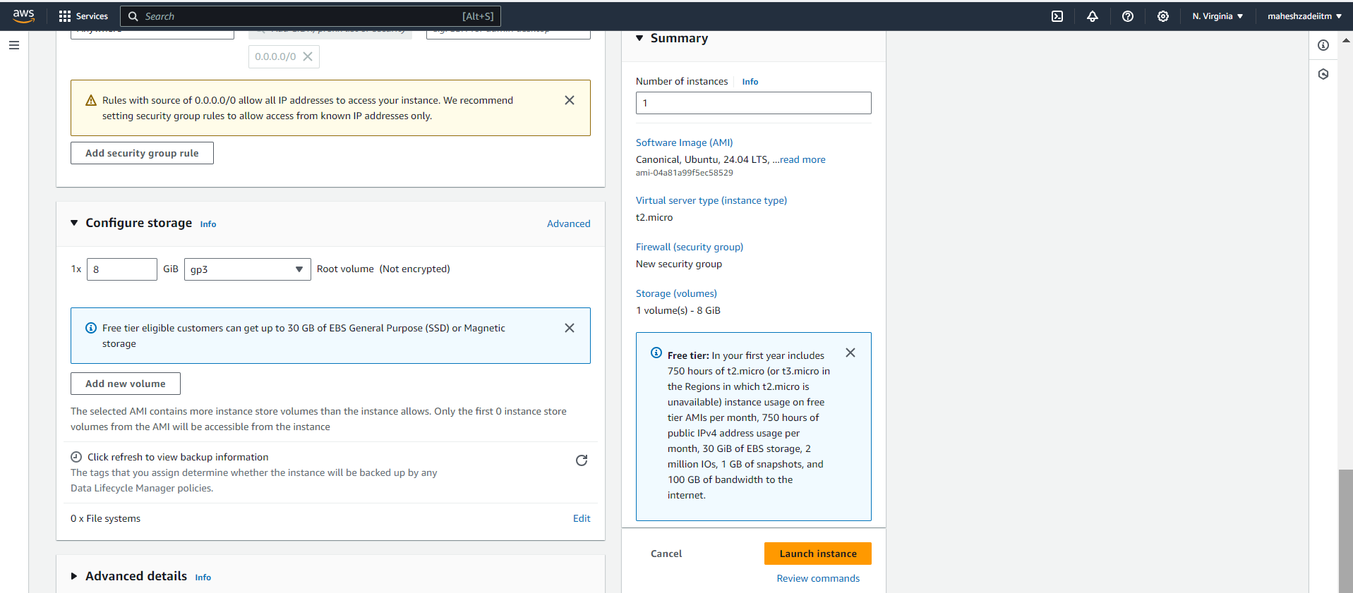

**AWS-Capstone project-1-EC2 instacne launched successfully**

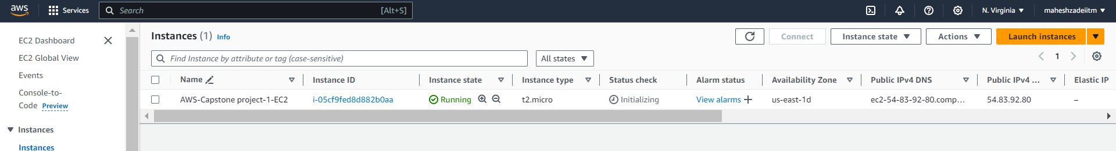

Now, let's connect to the EC2 instance by Mobaxterm

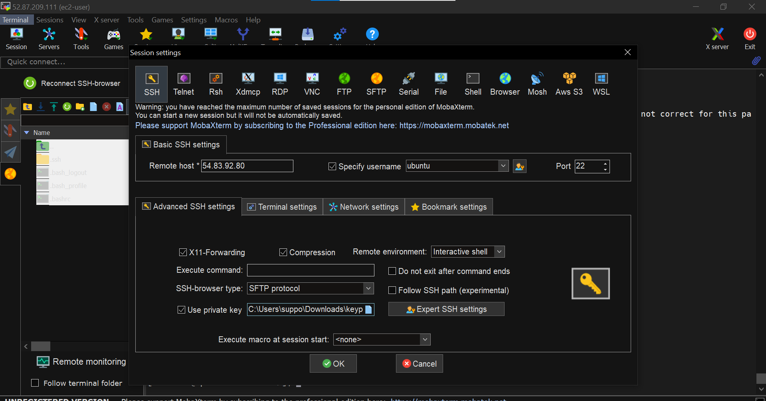

Instance is connected

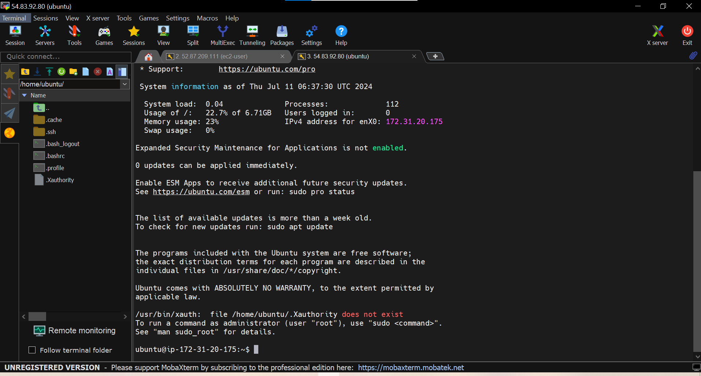

To configure Apache, firstly lets update the machine and follow it up by installing

Apache web server.

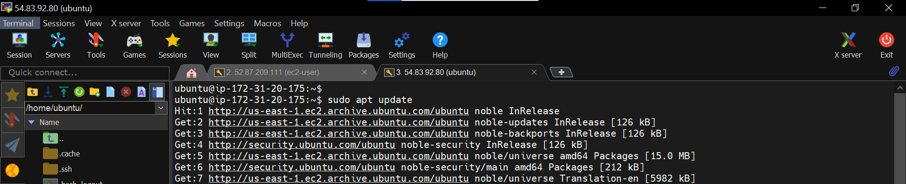

Now, To install Apache use the following command:

*sudo apt install apache2 -y*

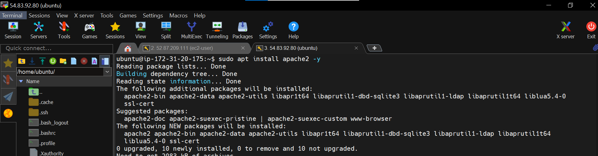

Copy and Paste the Public IP on the browser and you should be able to see the

default Apache page.

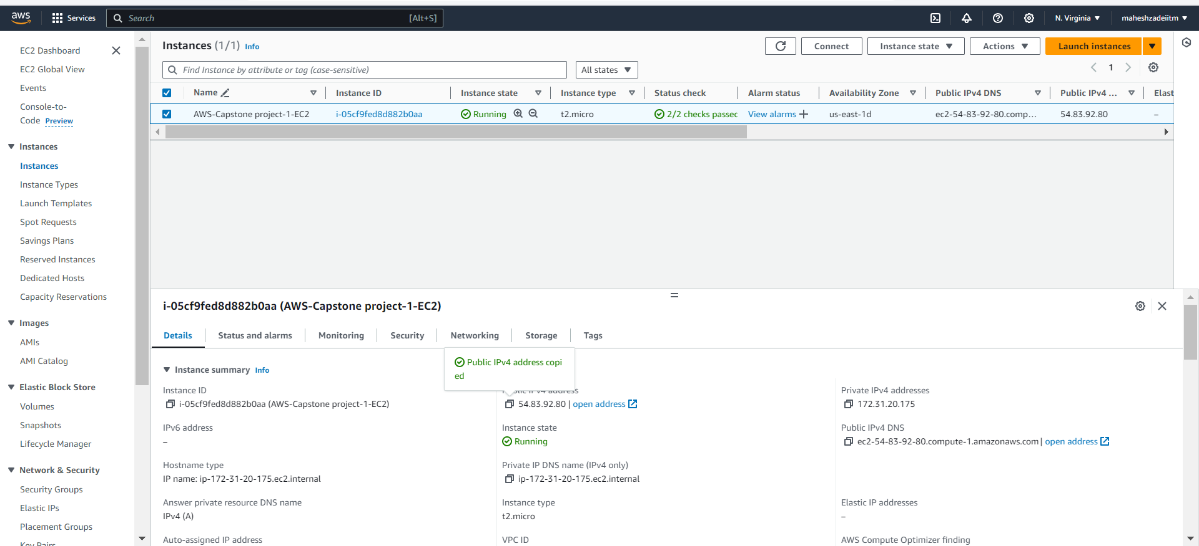

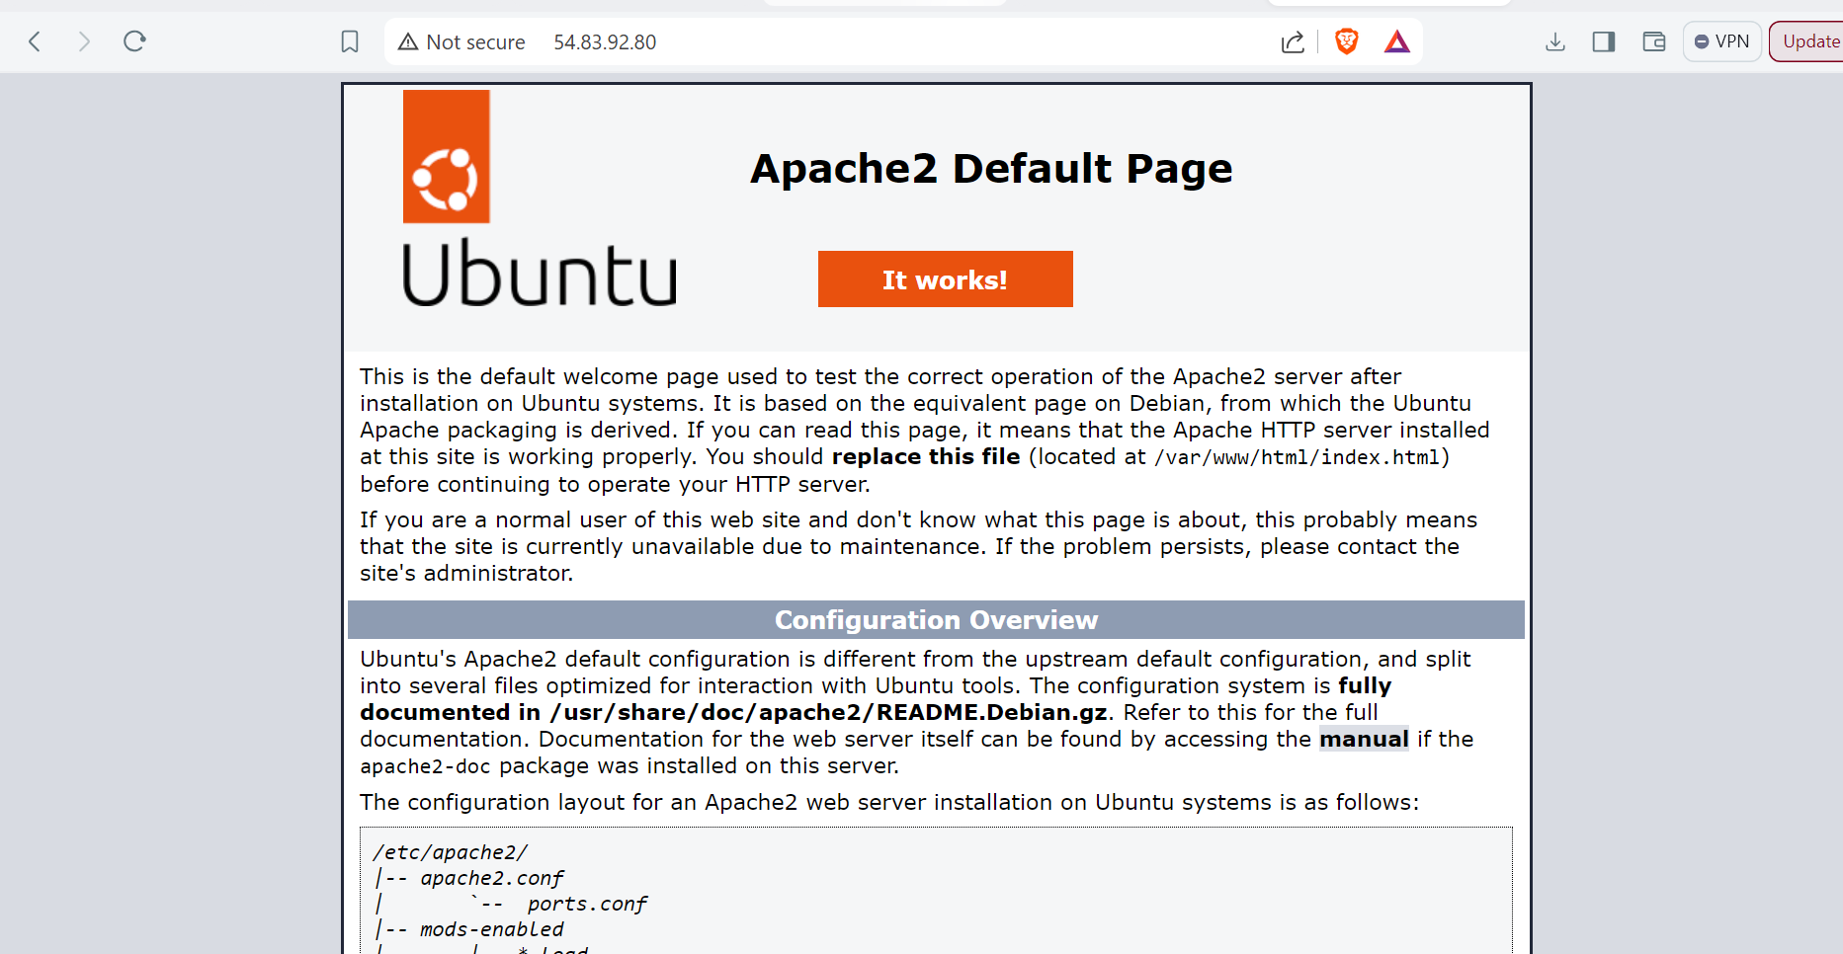

Now, we will replace the default Apache web page by content of our website. You

can refer to LMS portal to download the website code.

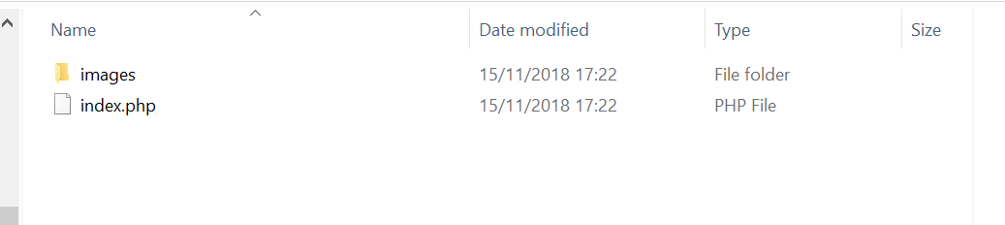

Now, when you list the items inside the **/var/www/html** directory, you can notice

**index.html** and **index.php** web pages. As i**ndex.html** is the default Apache page, we

don’t need it any longer as our main website is contained inside **index.php**.

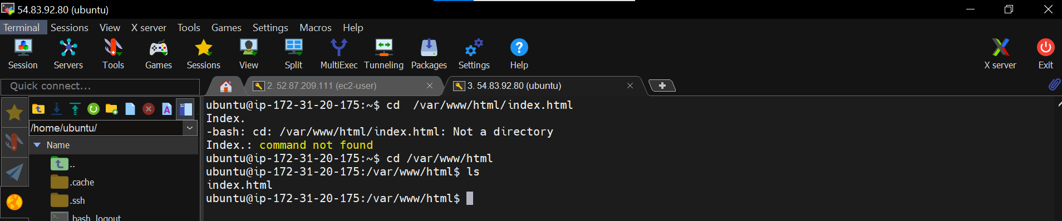

To delete the **index.html** page, use the command below:

*sudo rm /var/www/html/index.html*

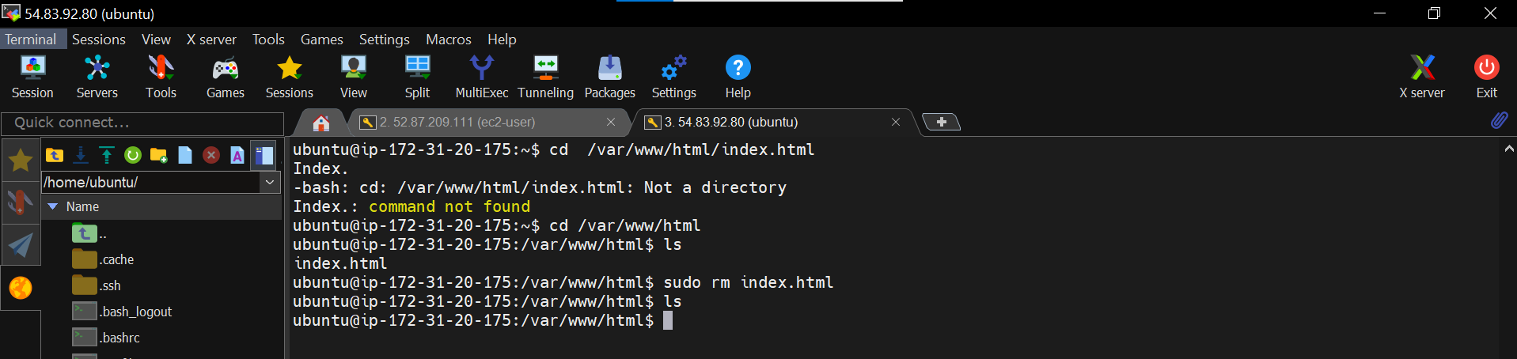

Now create the index.php file by nano command and open the download index.html file to copy the contents which we downloaded fromLMS Portal.

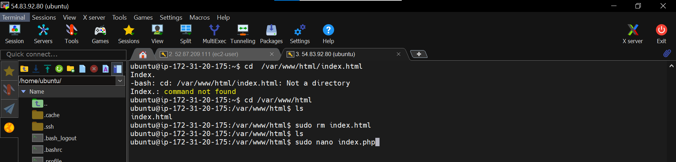

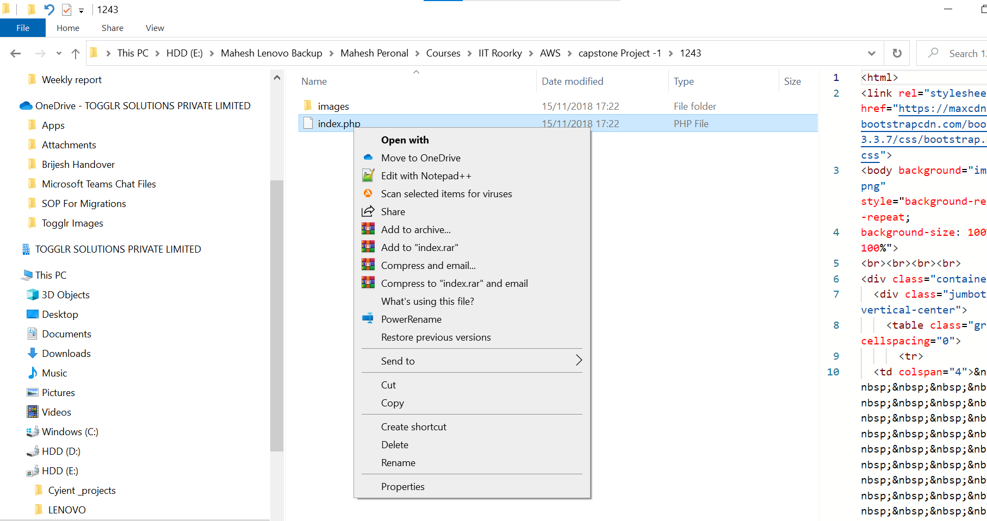

Copied the contents by nano commad in EC2 instacne

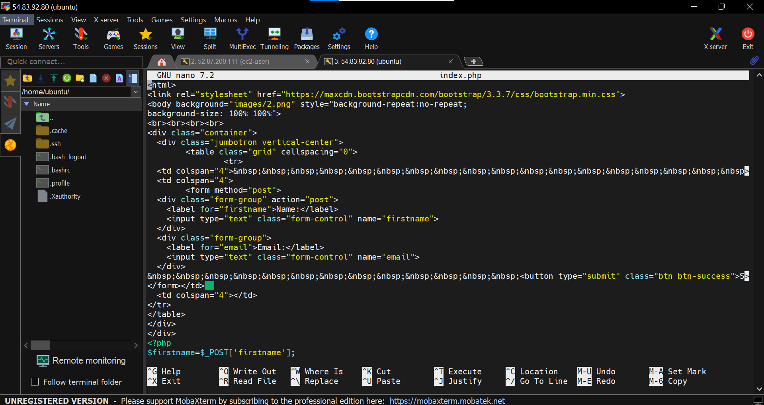

Now to save press ctrl +s and ctrl+x

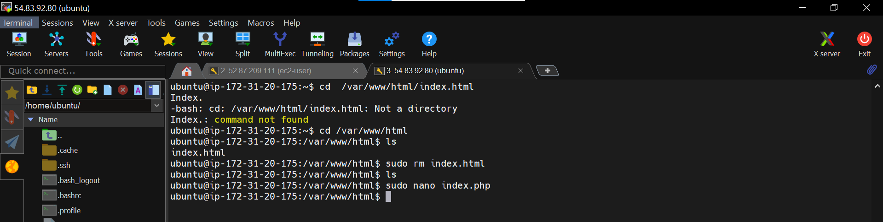

Index.html file is removed and now if you refresh the webpage in the browser, you

should be able to see the Php application.

Again copy the public IP and paste in the browser

As you can see, our Php application is up and running.

In the console output, it gives **Connection failed** issue as we haven’t set up a

database for this website yet.

In the upcoming steps, we will configure an RDS Instance to fulfill the requirements

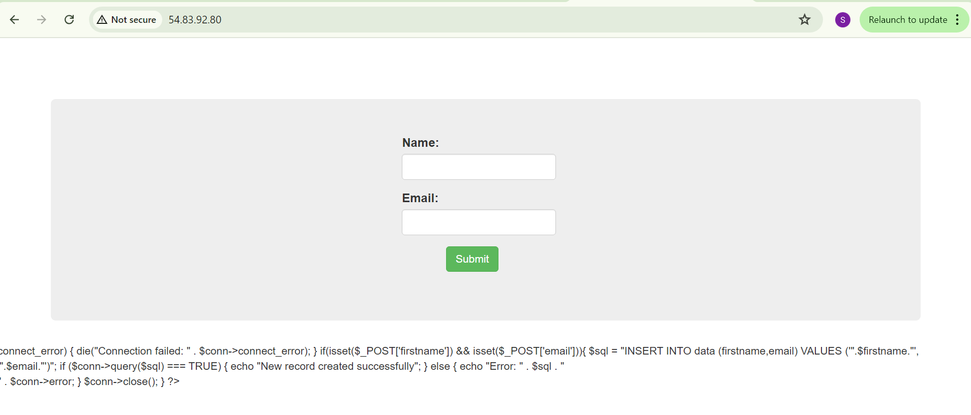

Lets create a **RDS MySQL** database now. Choose the options as shown below.

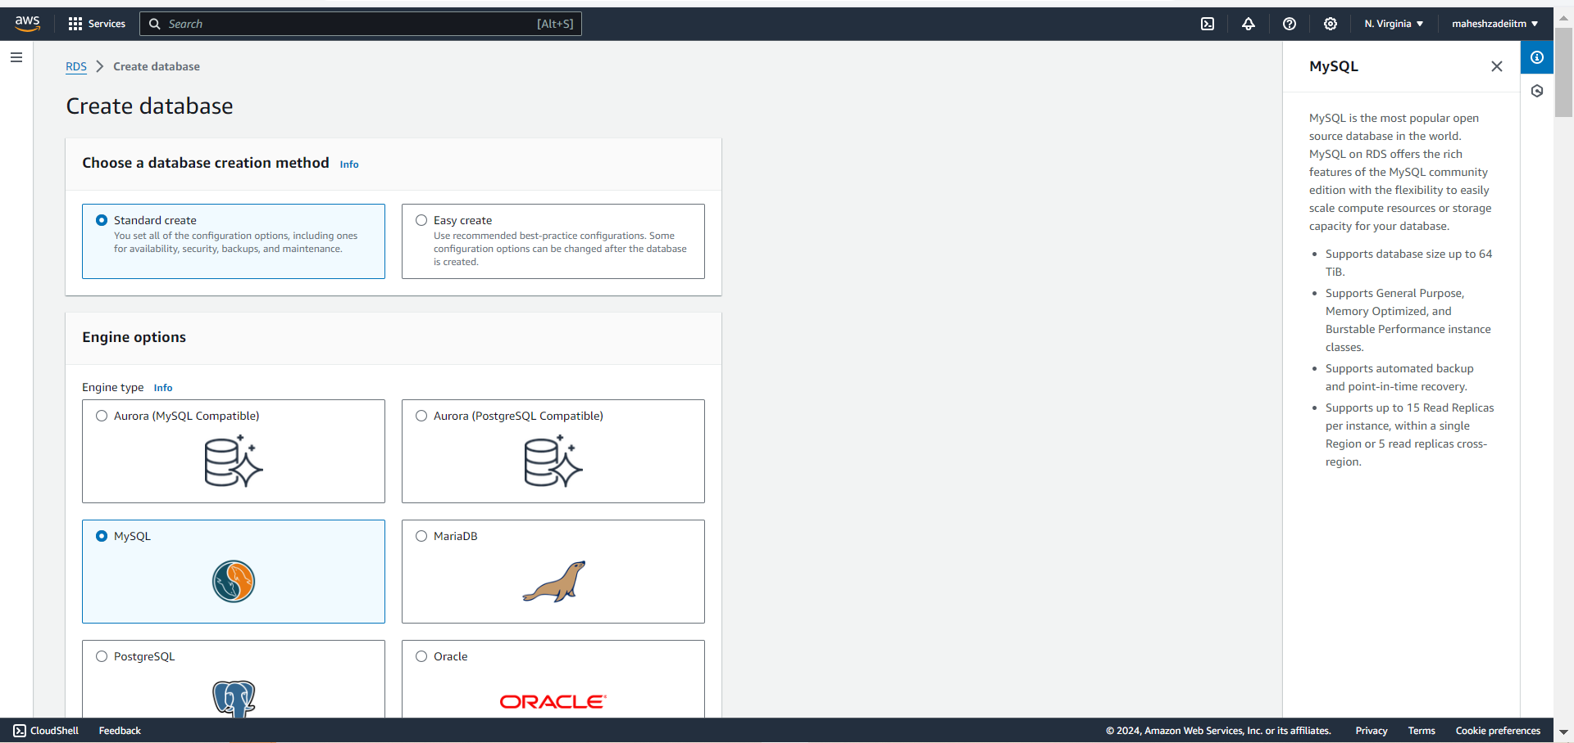

In **Templates**, Choose **Free Tier**.

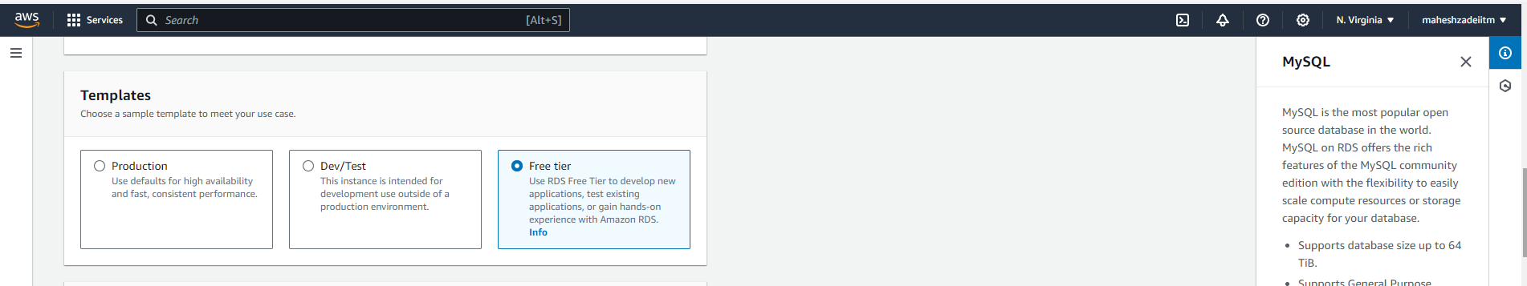

Now, provide the credentials as shown below and make sure to keep note of **master**

**Username ( admin)** and **password**.( intel123)

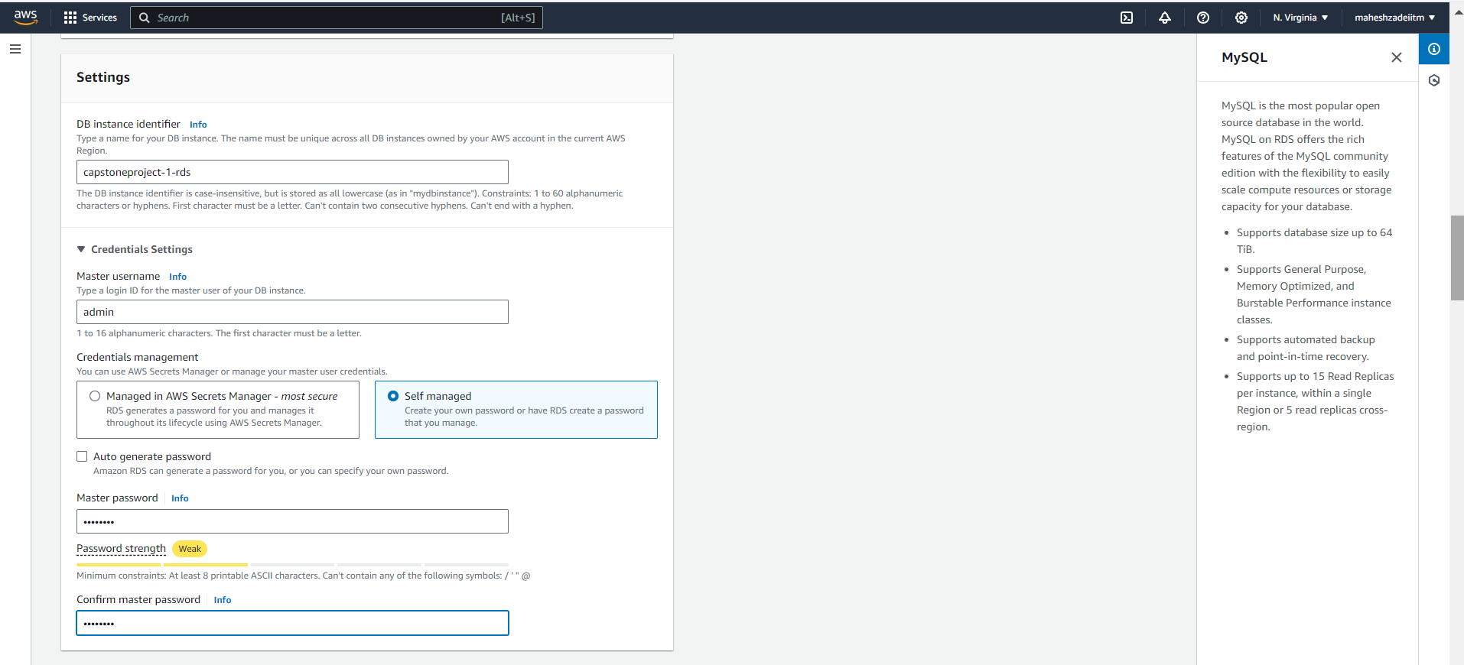

Choose the **minimum storage allocation**.

In **Storage Autoscaling,** You can either go with **enabled** or **disabled** based on your

preference.

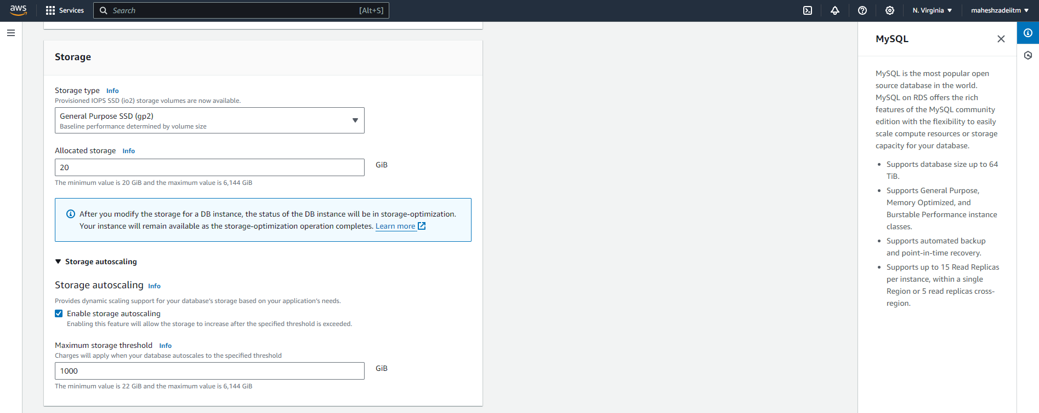

**Connectivity**, Choose the options as shown below. Make sure you choose **Public**

**Access** as **No** as the database is meant to be private.

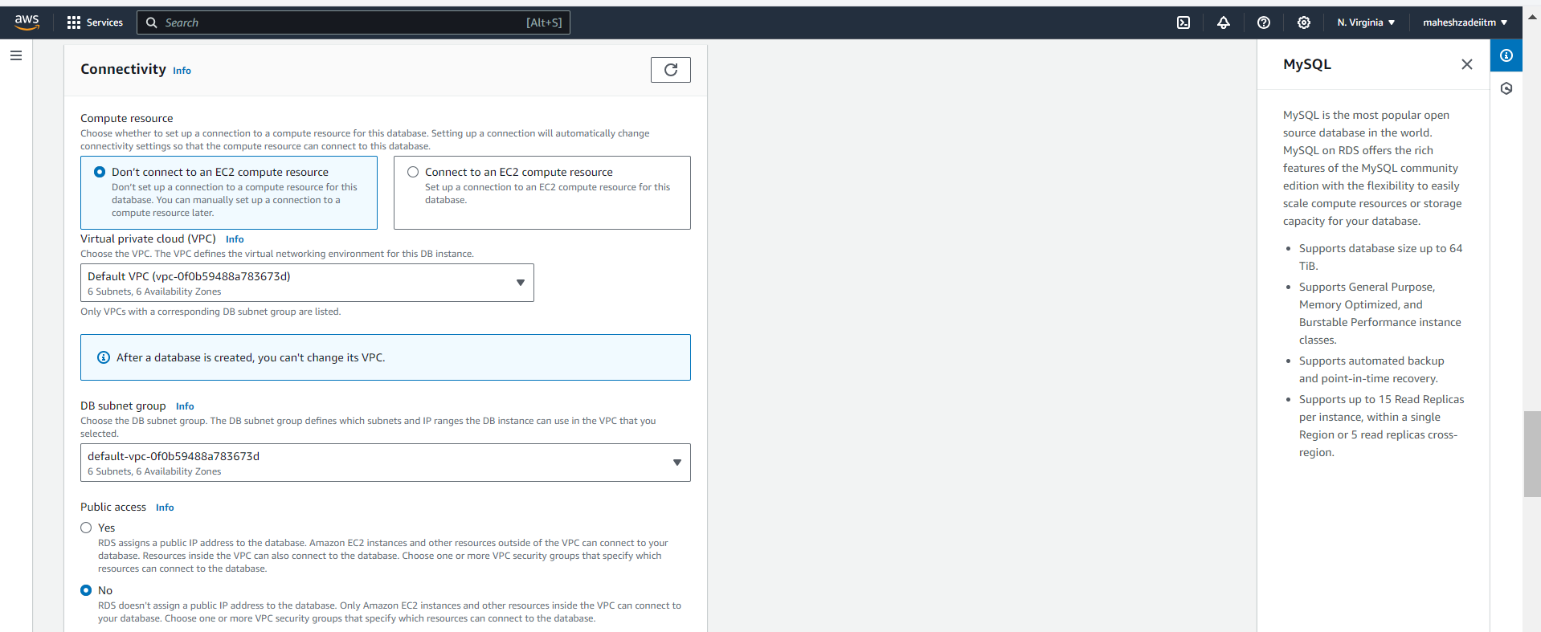

Create a **new security group** and provide a name, it will create a rule allowing

necessary inbound traffic to this database through port **3306 ( MySQL/Aurora)**

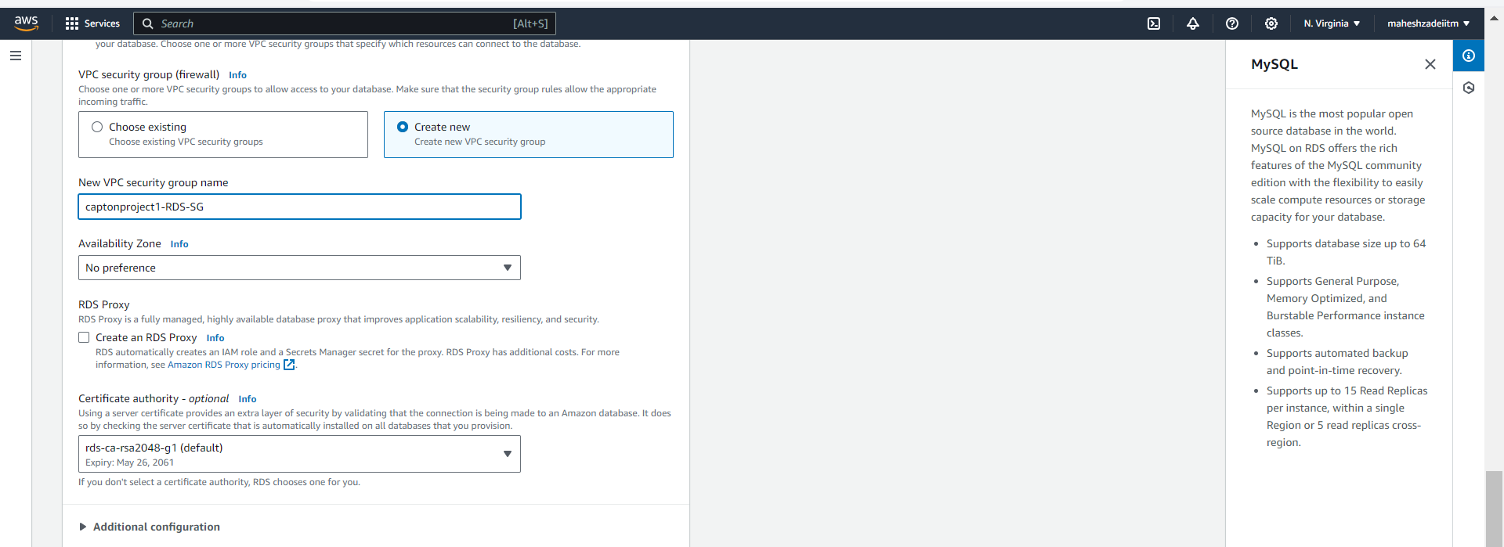

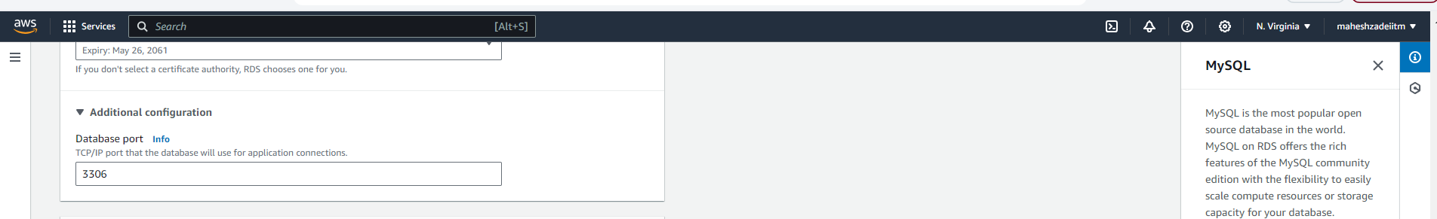

In **Additional Configuration**, provide the **initial database name** as per the problem

statement.

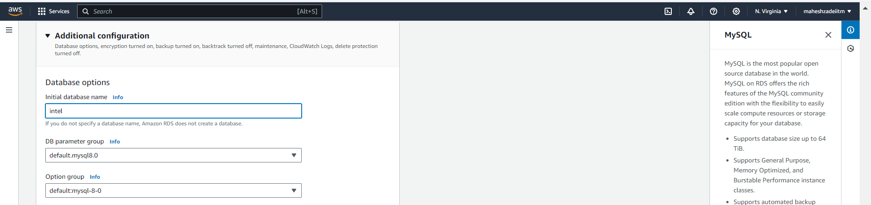

**Rest keep the settings as it is**

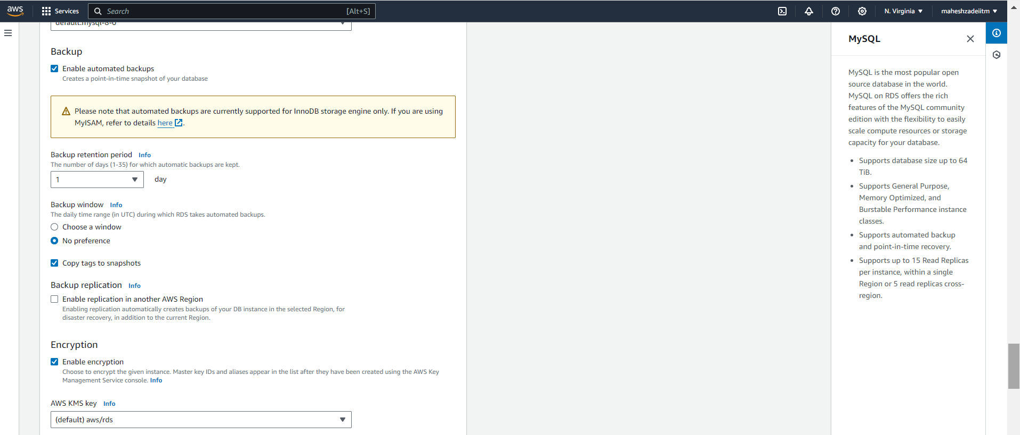

Wait for a few minutes until RDS Instance is created.

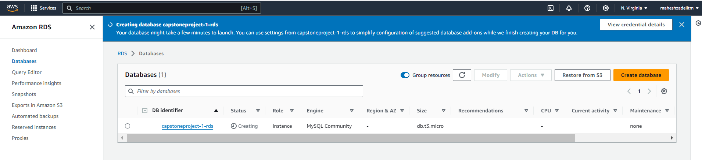

**Database created successfully**

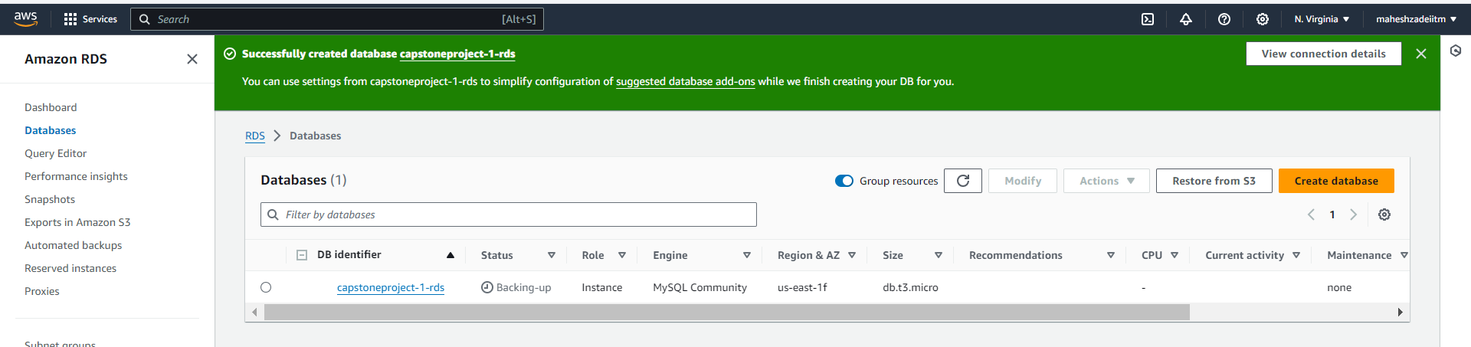

Note down the **RDS Endpoint** and **port**, as we will need it later on while connecting

our EC2 server with this database.

Endpoint

capstoneproject-1-rds.cni66oma0d3m.us-east-1.rds.amazonaws.com

port

3306

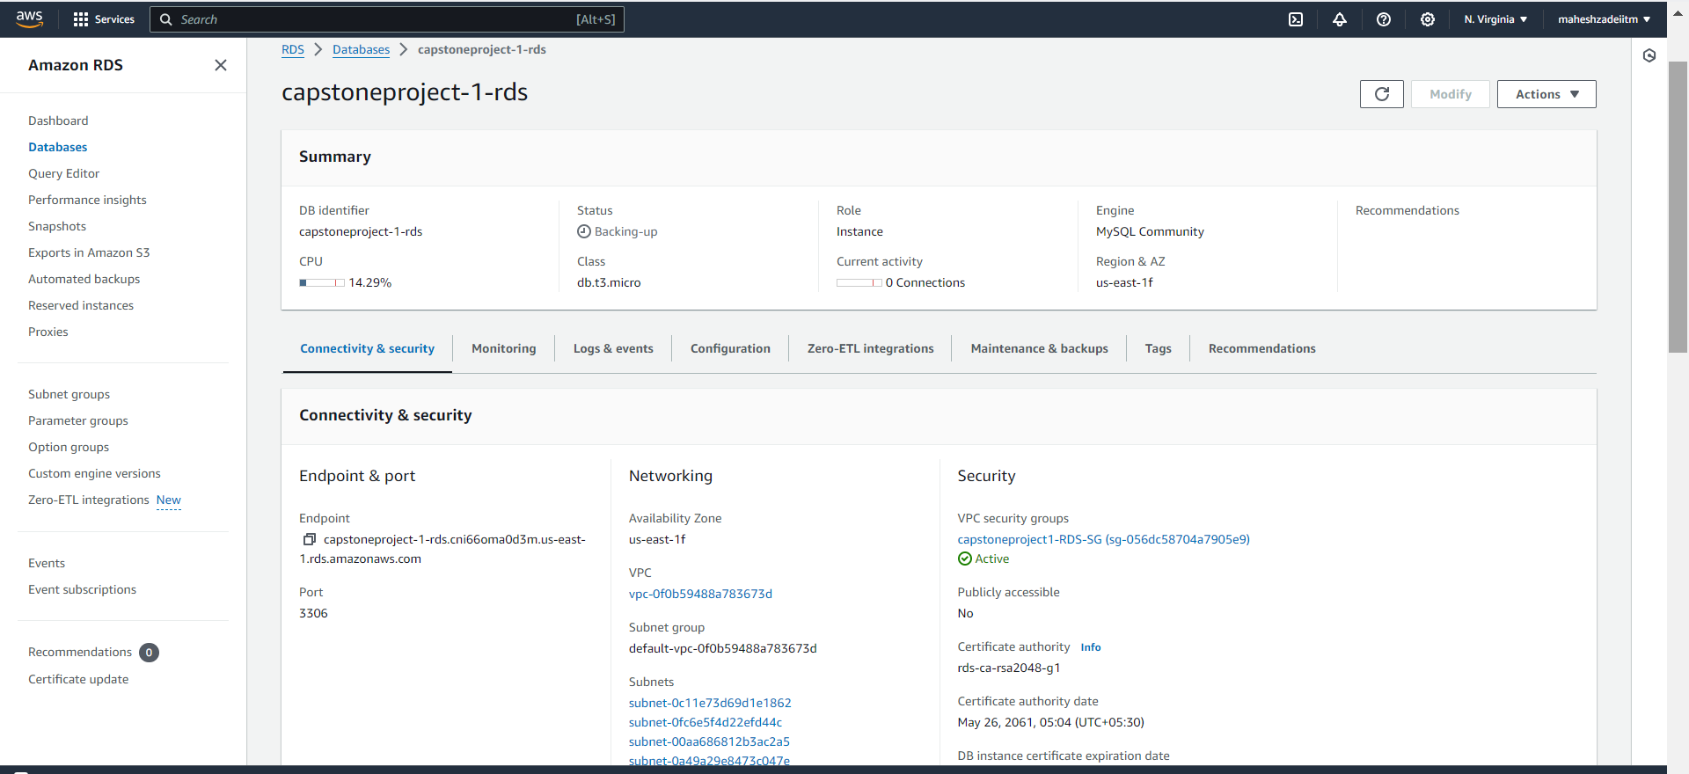

Now, Click on [capstoneproject1-RDS-SG](https://us-east-1.console.aws.amazon.com/ec2/v2/home?region=us-east-1#SecurityGroups:search=sg-056dc58704a7905e9), as we will need to modify its inbound rules to allow

necessary traffic

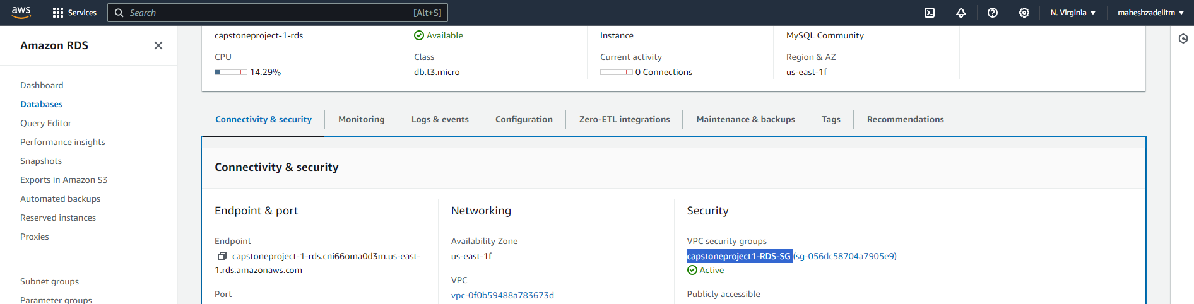

**Edit inbound Rule**

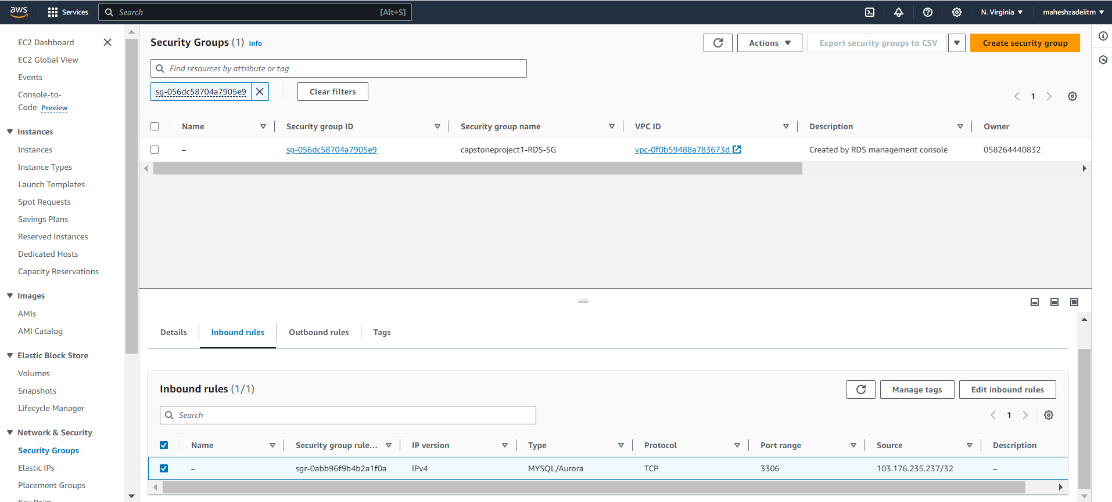

Here, you can see the connections are allowed from a **certain IP**. This can become a

bottleneck later on if we have multiple servers with the same application that share

the same database instance.

We will change this rule to allow **all possible IP addresses**.

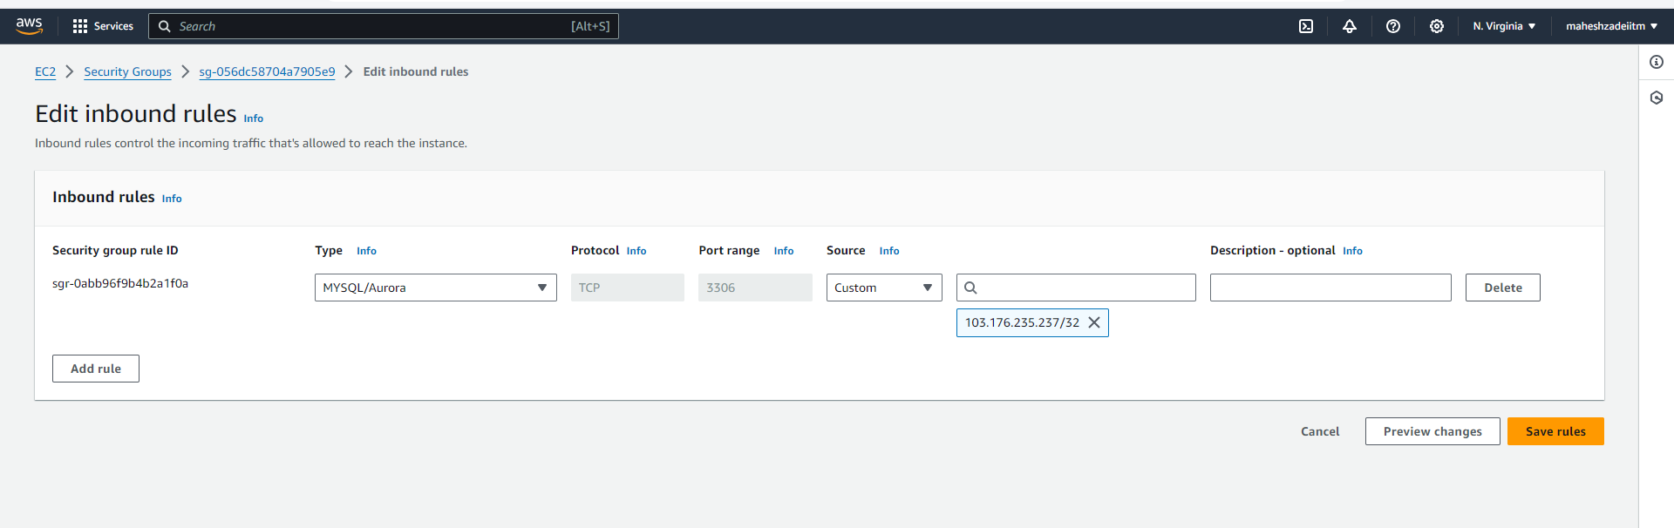

Allow the traffic from source **0.0.0.0/0**.

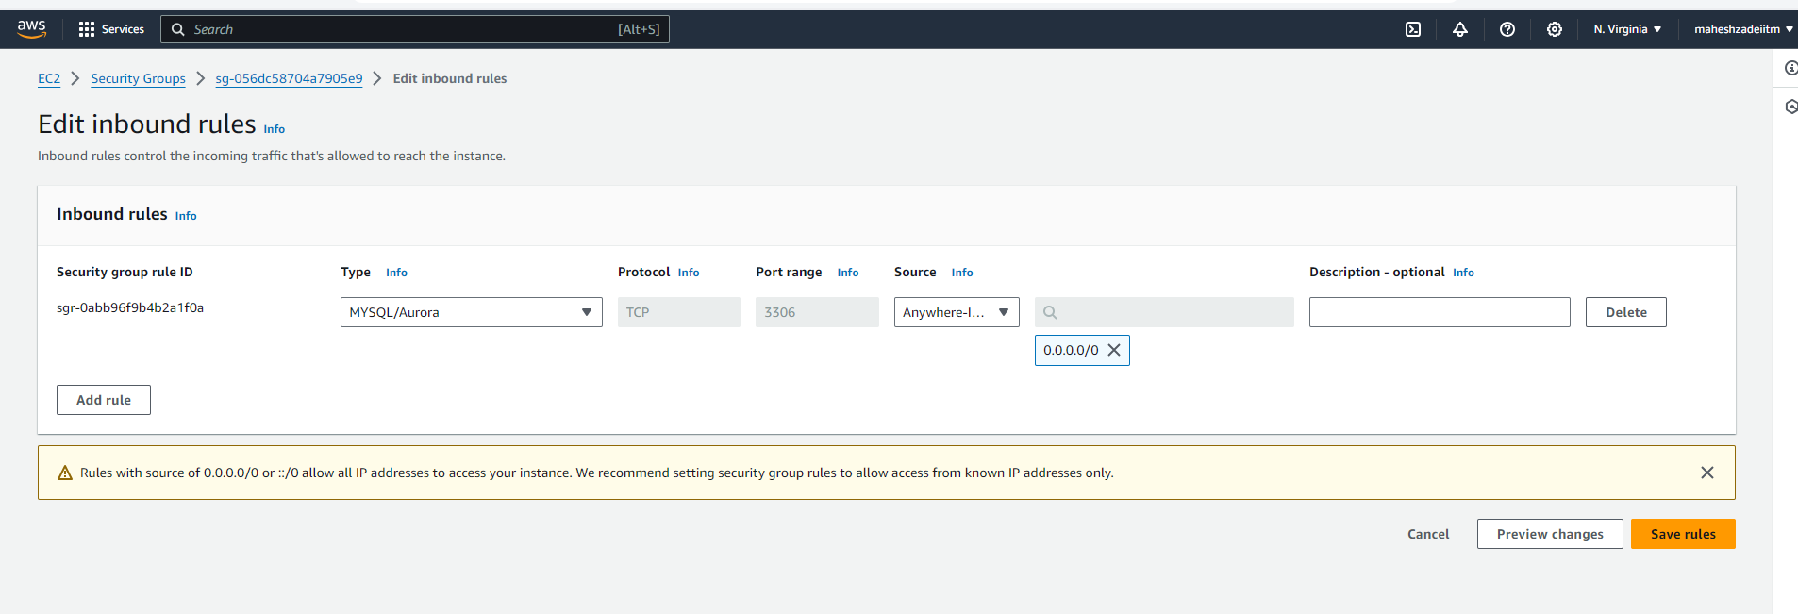

Now, let's head back to the EC2-server and install **Mysql** Packages that are

compatible with our PHP application.

Import the repository and install the packages using the commands below:

*sudo add-apt-repository -y ppa:ondrej/php*

*sudo apt install php5.6 mysql-client php5.6-mysqli*

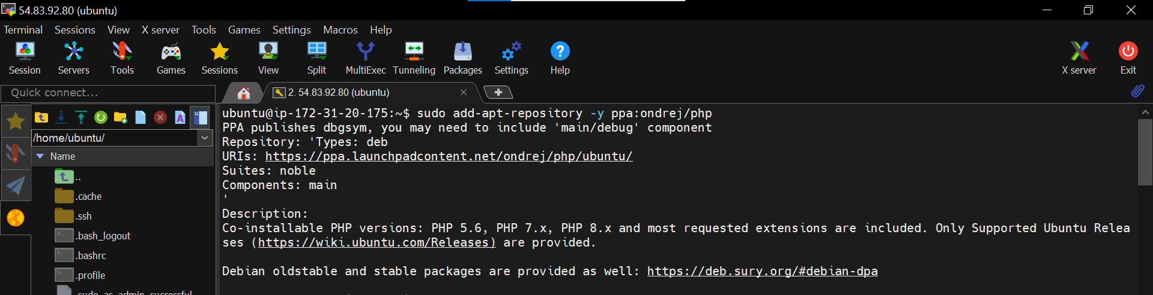

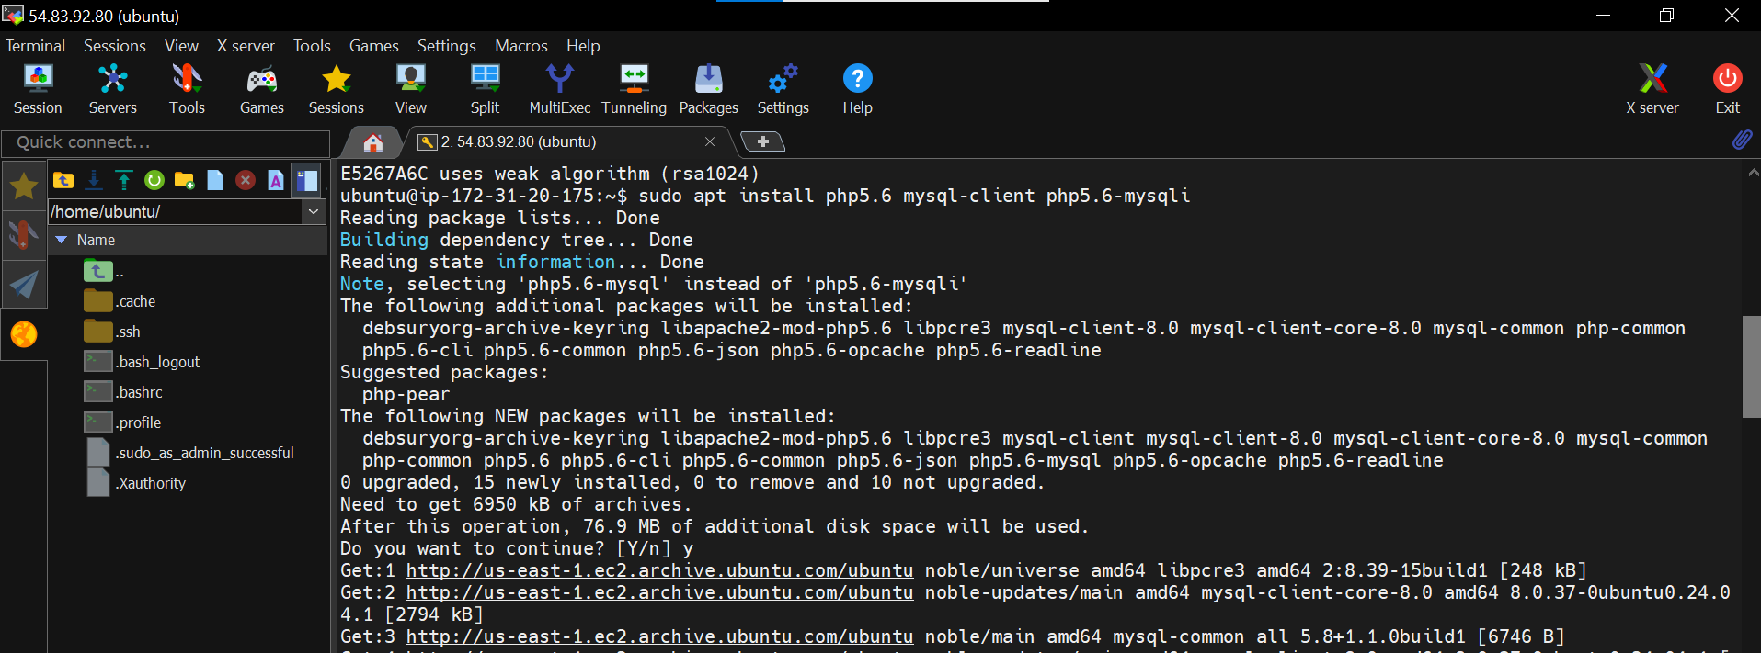

Now, we will connect with our RDS Instance and create a table in the database to

store the user data coming through the application.

Copy the **RDS endpoint** and head back to the EC2 server.

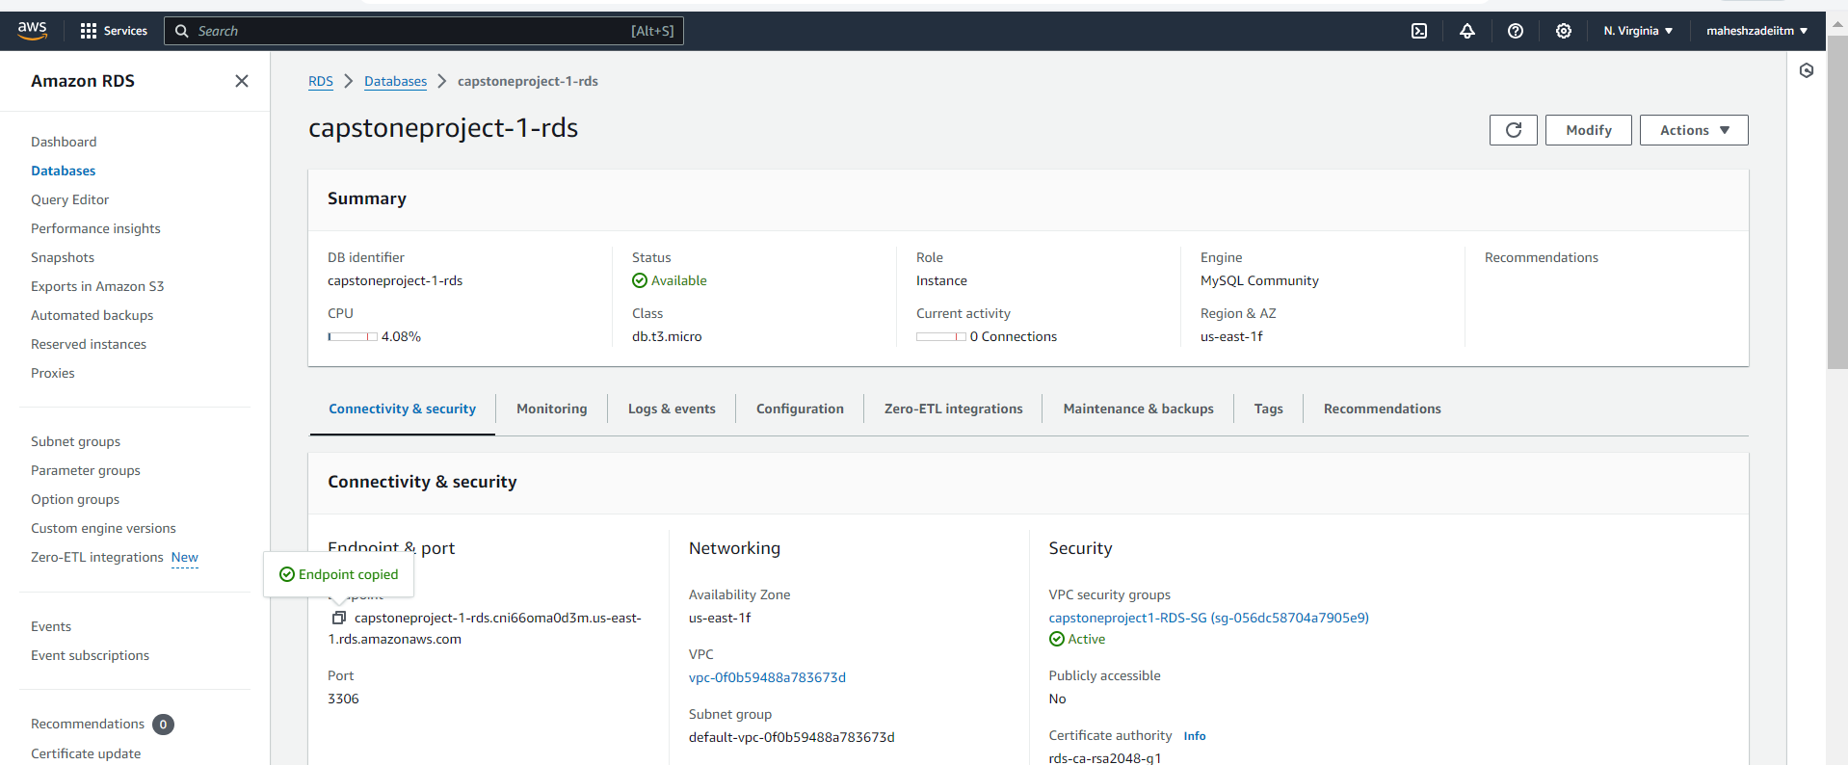

Use the command as shown below.

Replace **RDS endpoint**, **username** credentials according to your RDS Instance.

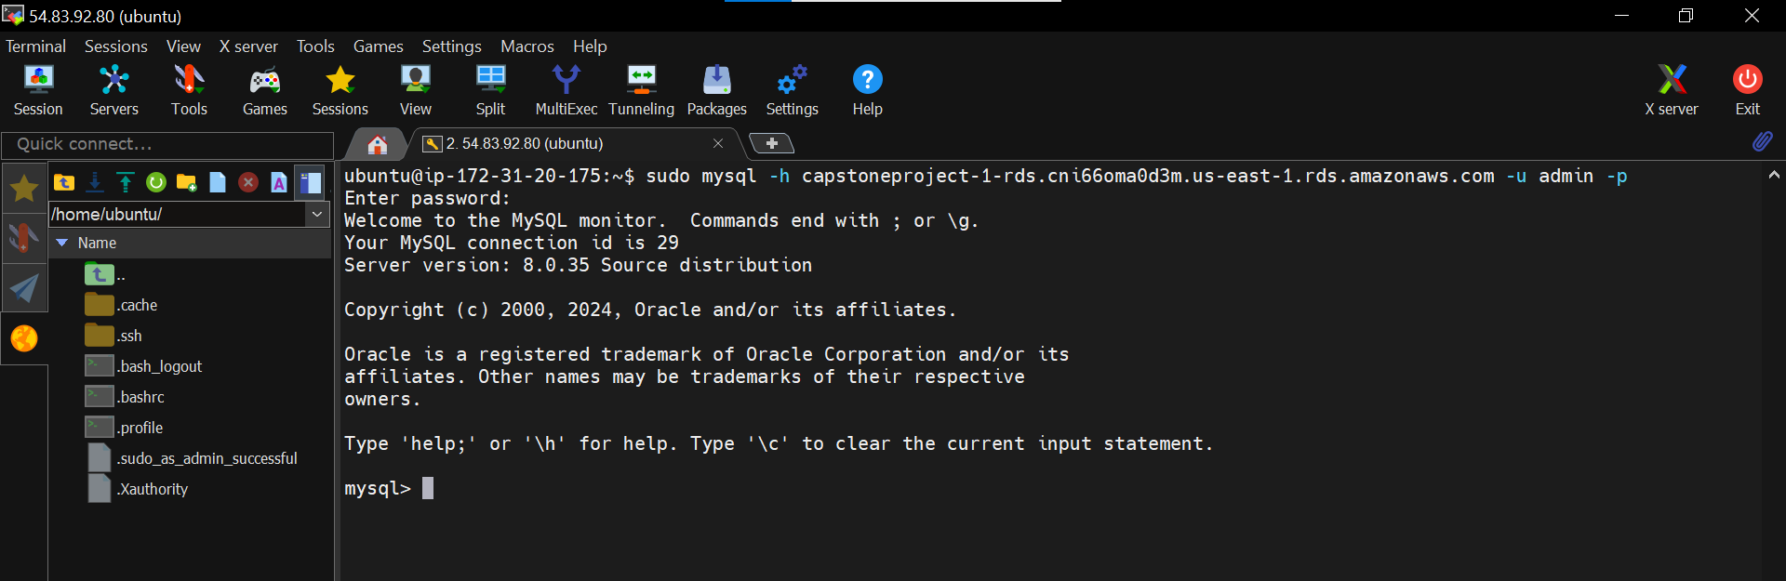

After connecting to the database, use the command below to list available

databases:

*show databases;*

You can see the initial database available here:

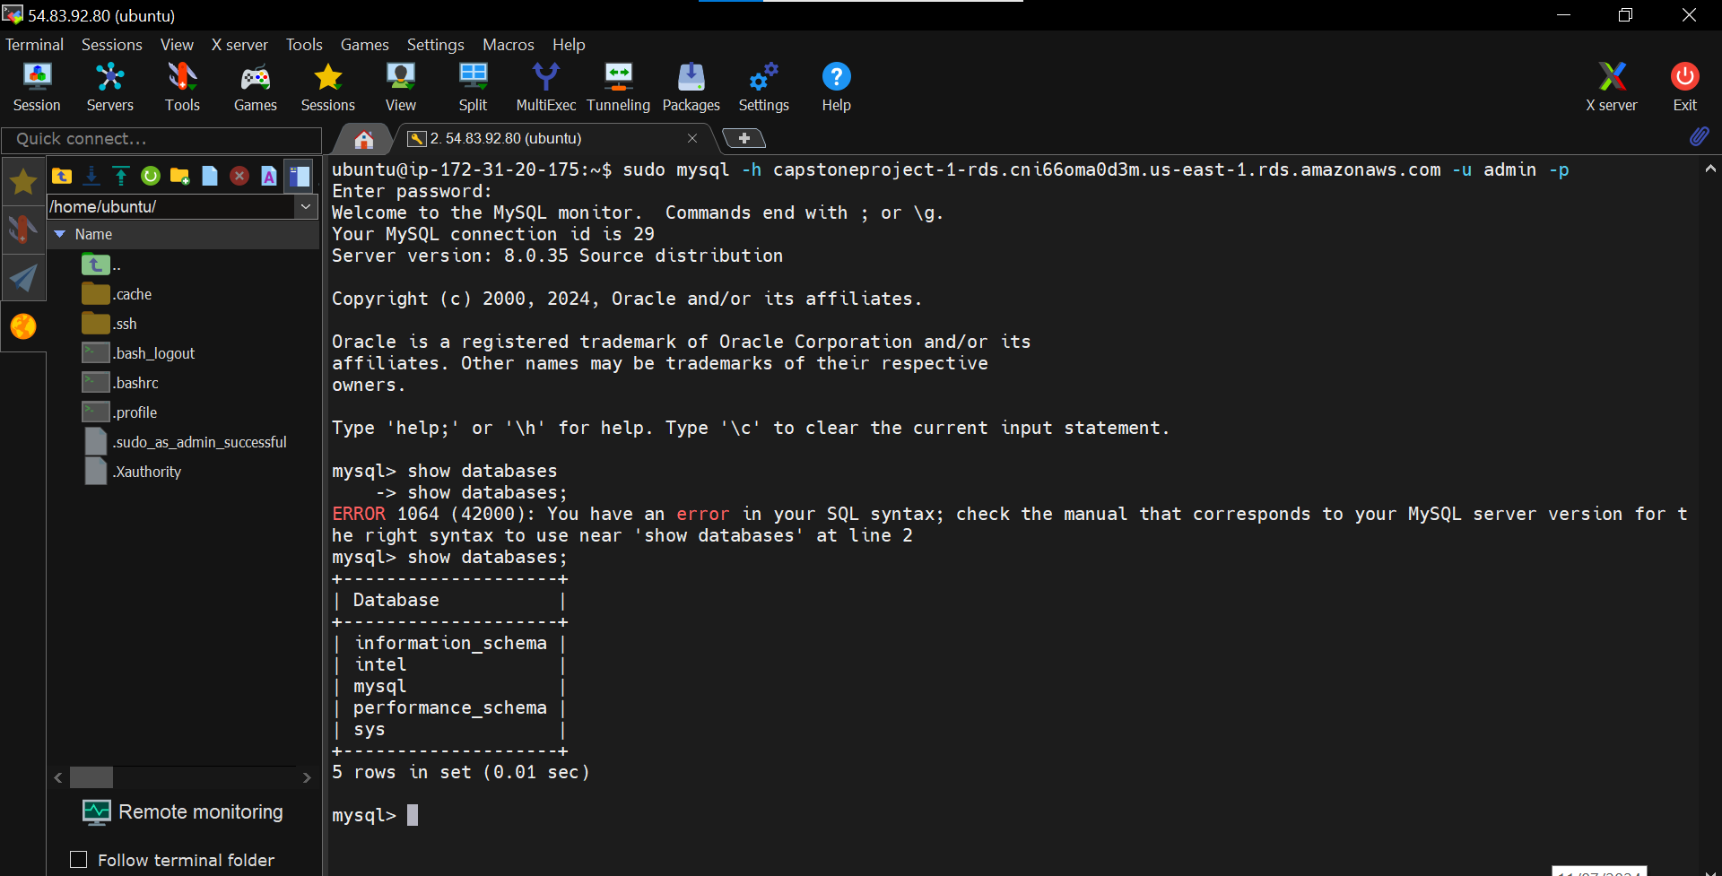

To change the database use the command below:

*use intel;*

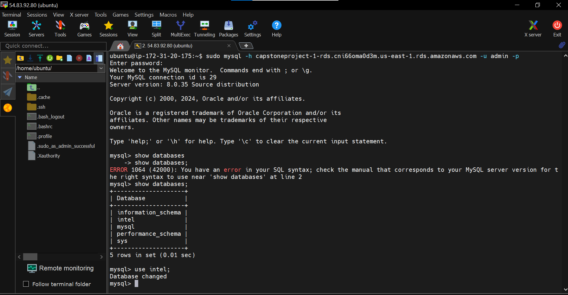

To create table use the command below:

*create table data(firstname varchar(21),email varchar(21));*

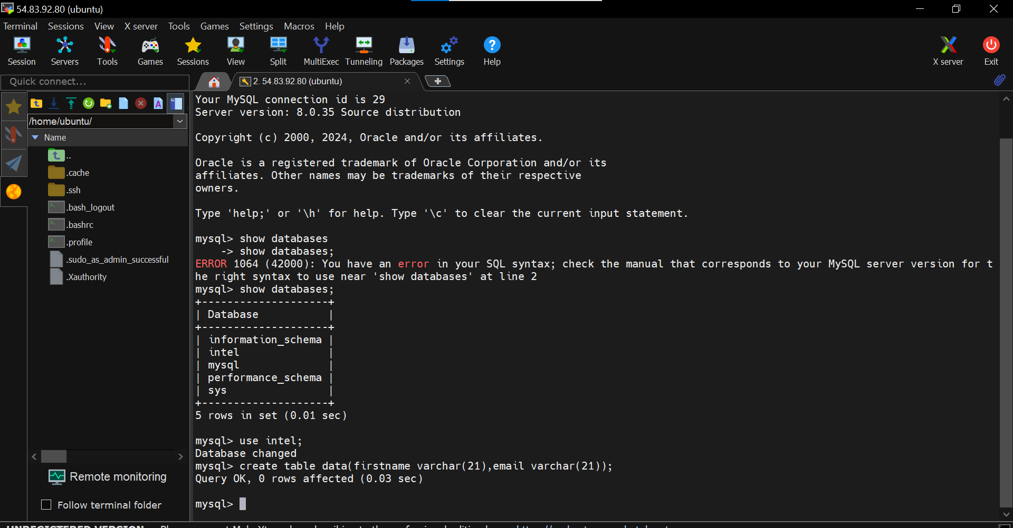

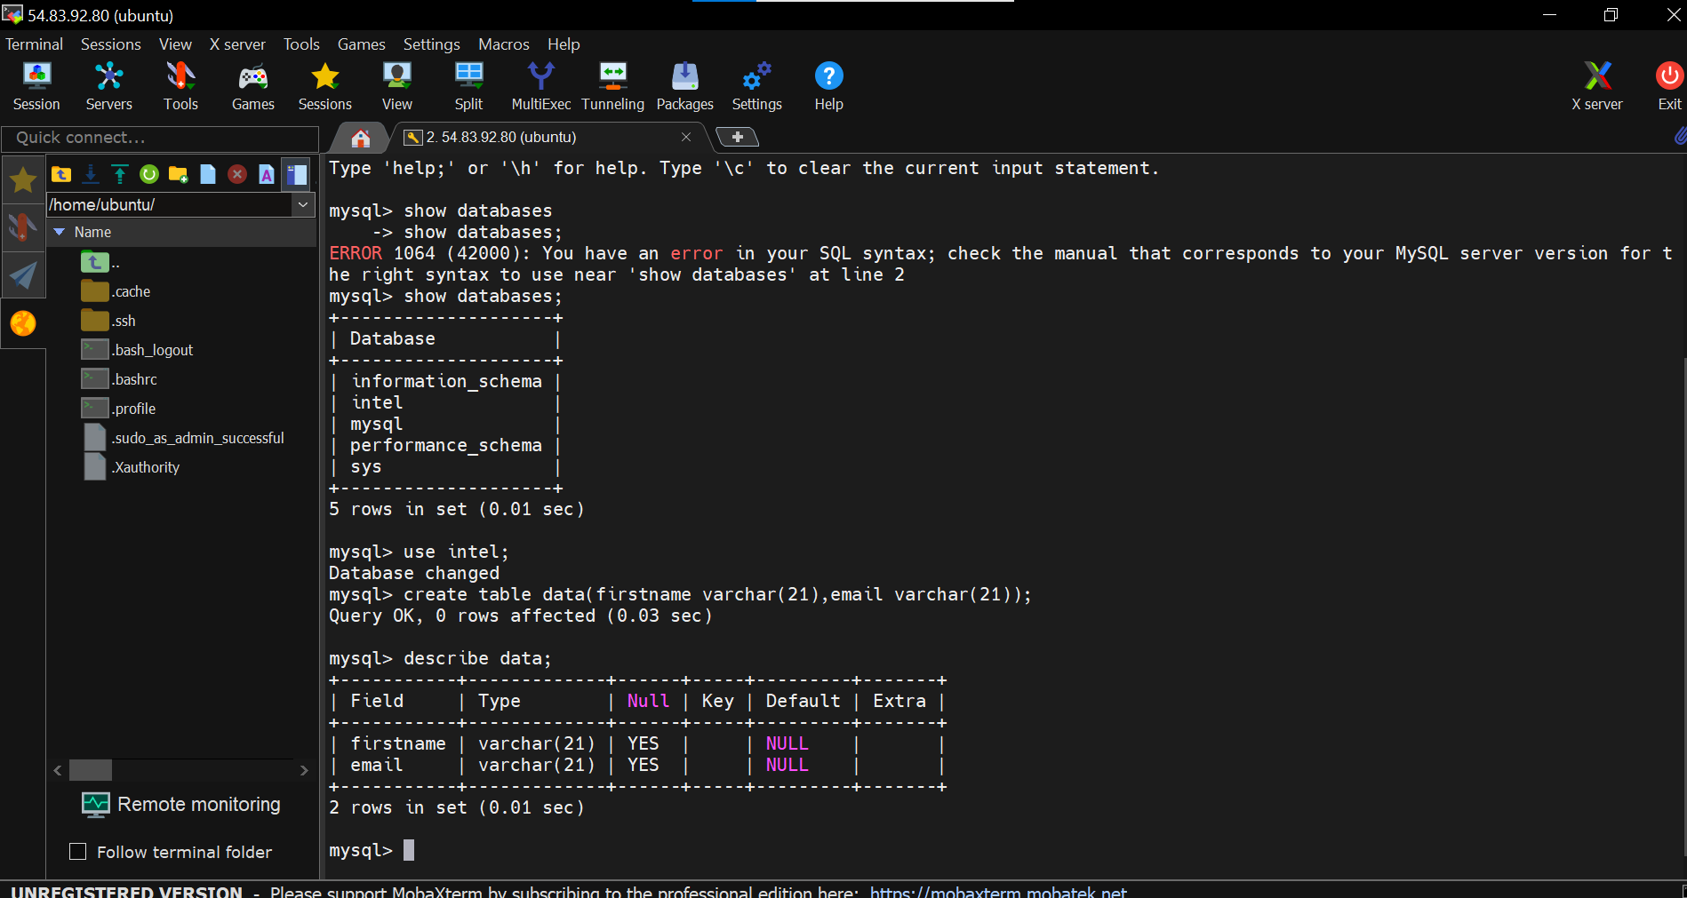

Table is created. Use **exit** to quit the Mysql shell.

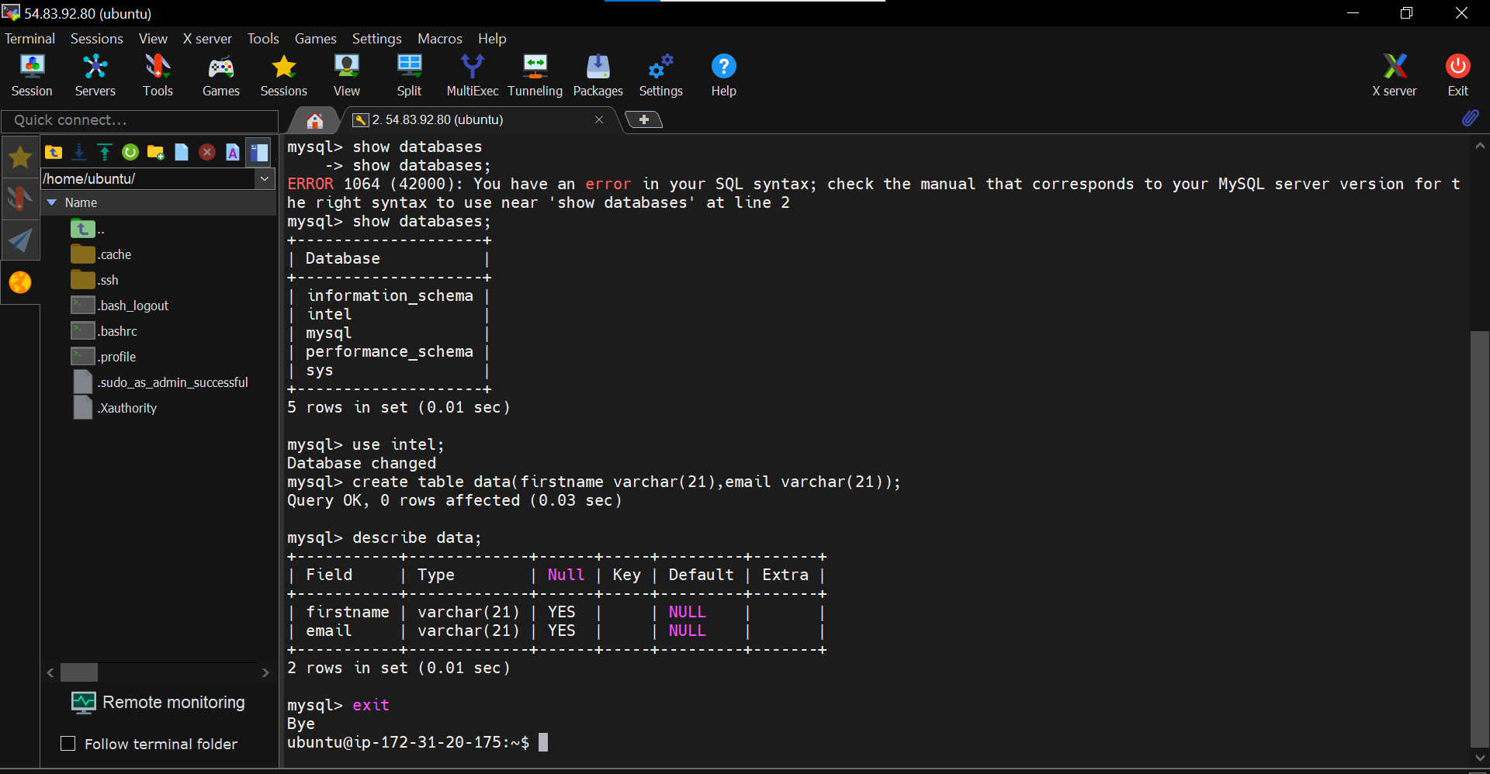

Now, it's time we integrate this database with our website.

Open the **index.php** file in the nano editor.

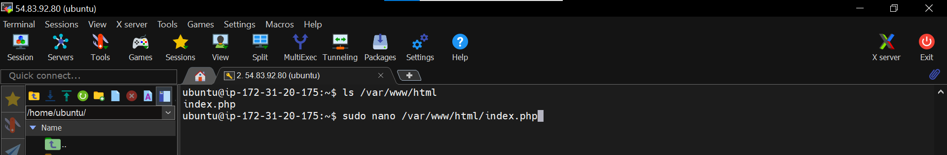

This is how our code looks

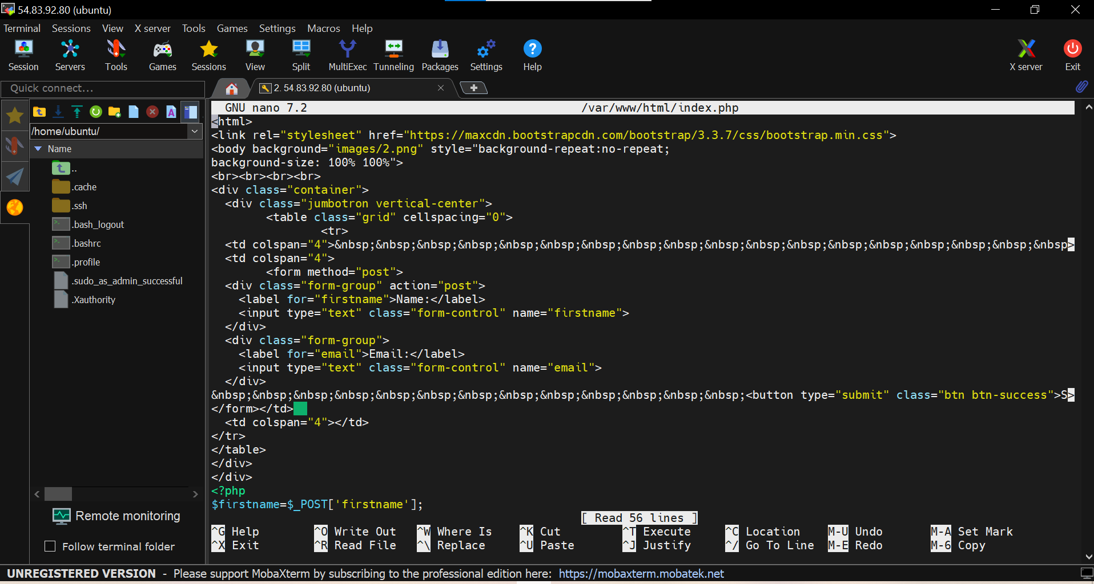

Scroll down to this line, where we need to update the database credentials.

Update **servername**, **username**, **password** and **database name**.

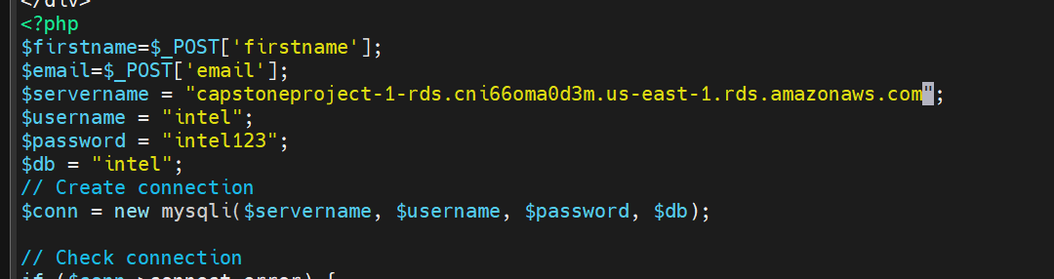

Now, credentials are updated and it is now integrated with our RDS database



**Save the file by ctrl+s and ctrl+x**

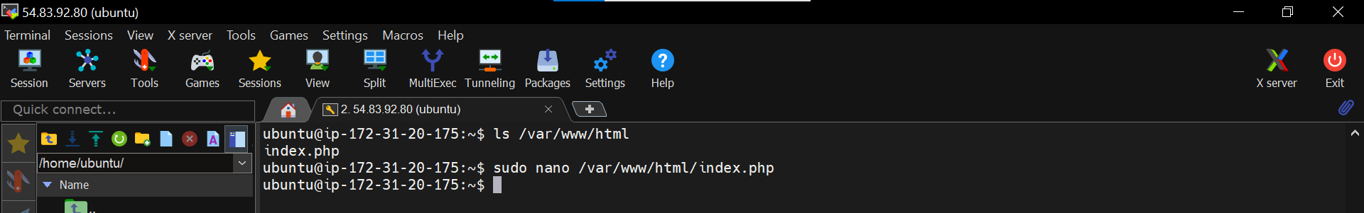

Now, refresh the page and you should be able to see that the console output which

was showing an error is now rectified and now we are ready to use this application.

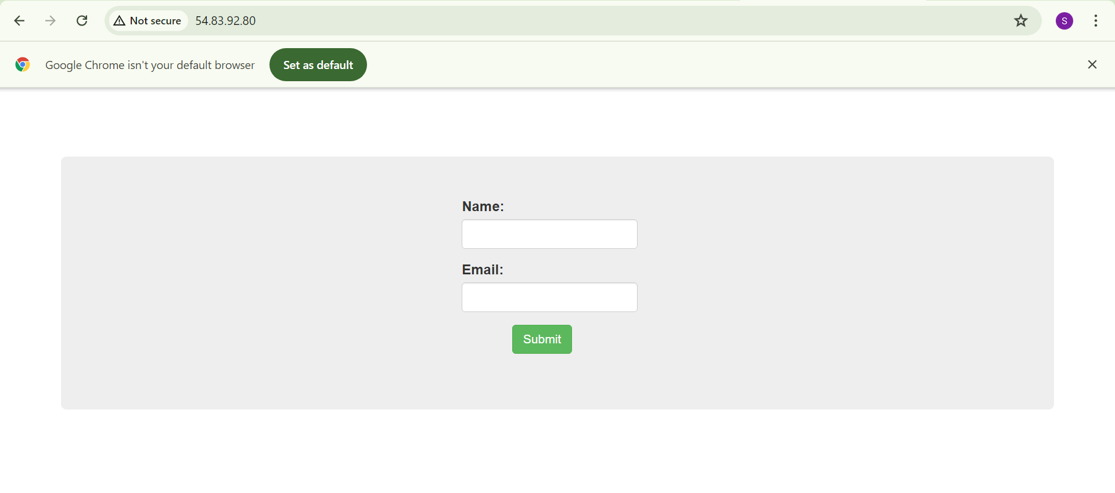

Provide the **Name** and **Email** and click on **Submit**.

You will see a console output suggesting “ **New record updated successfully**

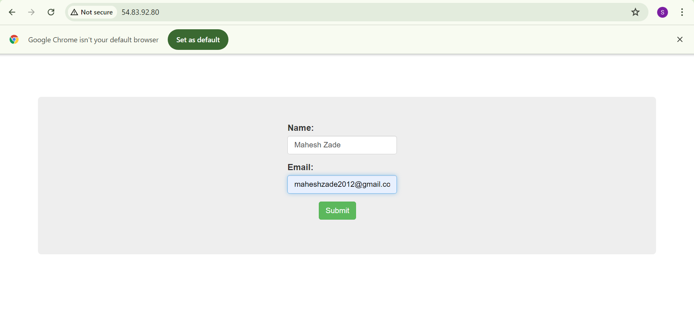

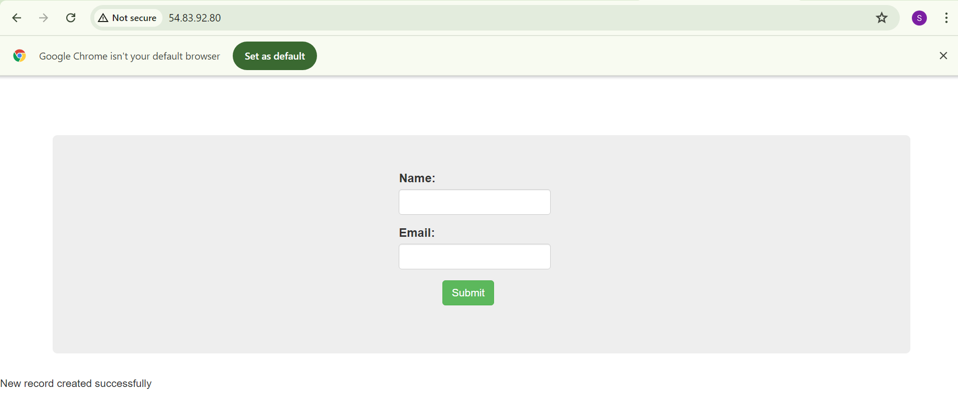

Now, lets connect to our MySQL database again and verify whether the database

has new entries from the application.

Database is connected

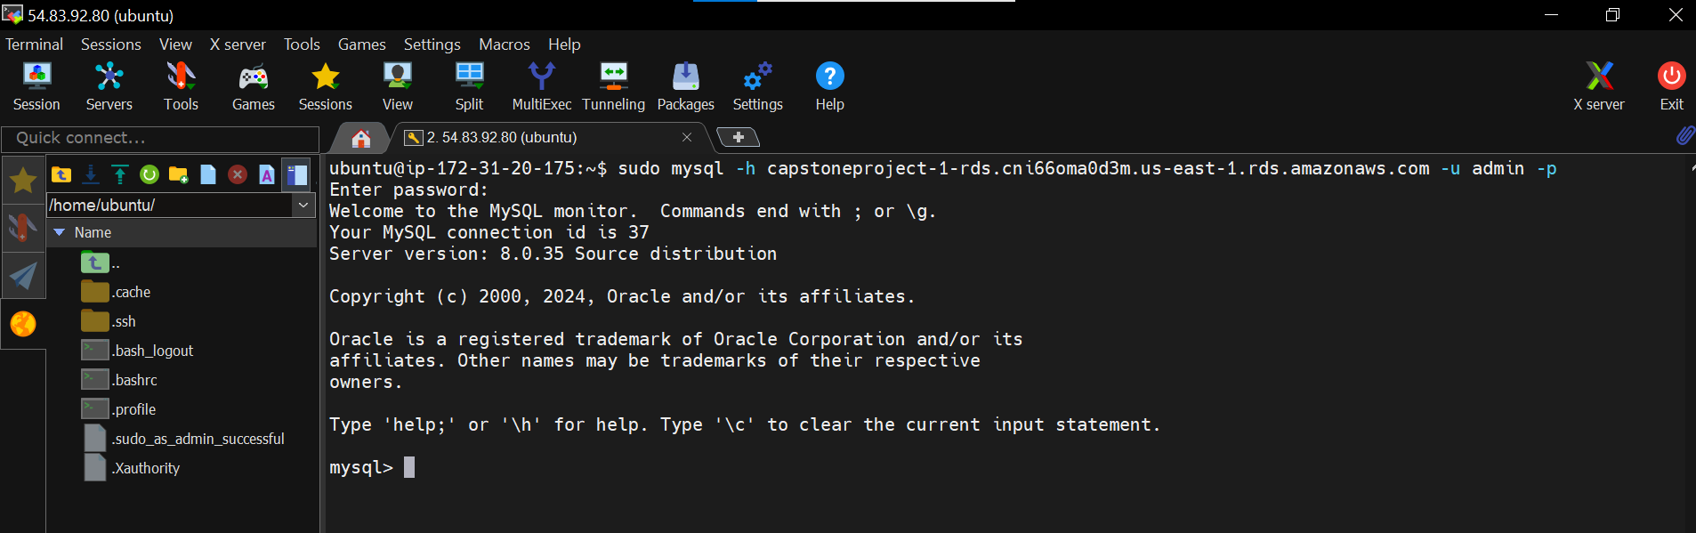

Change the database to **intel**.

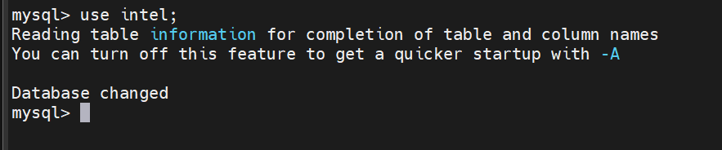

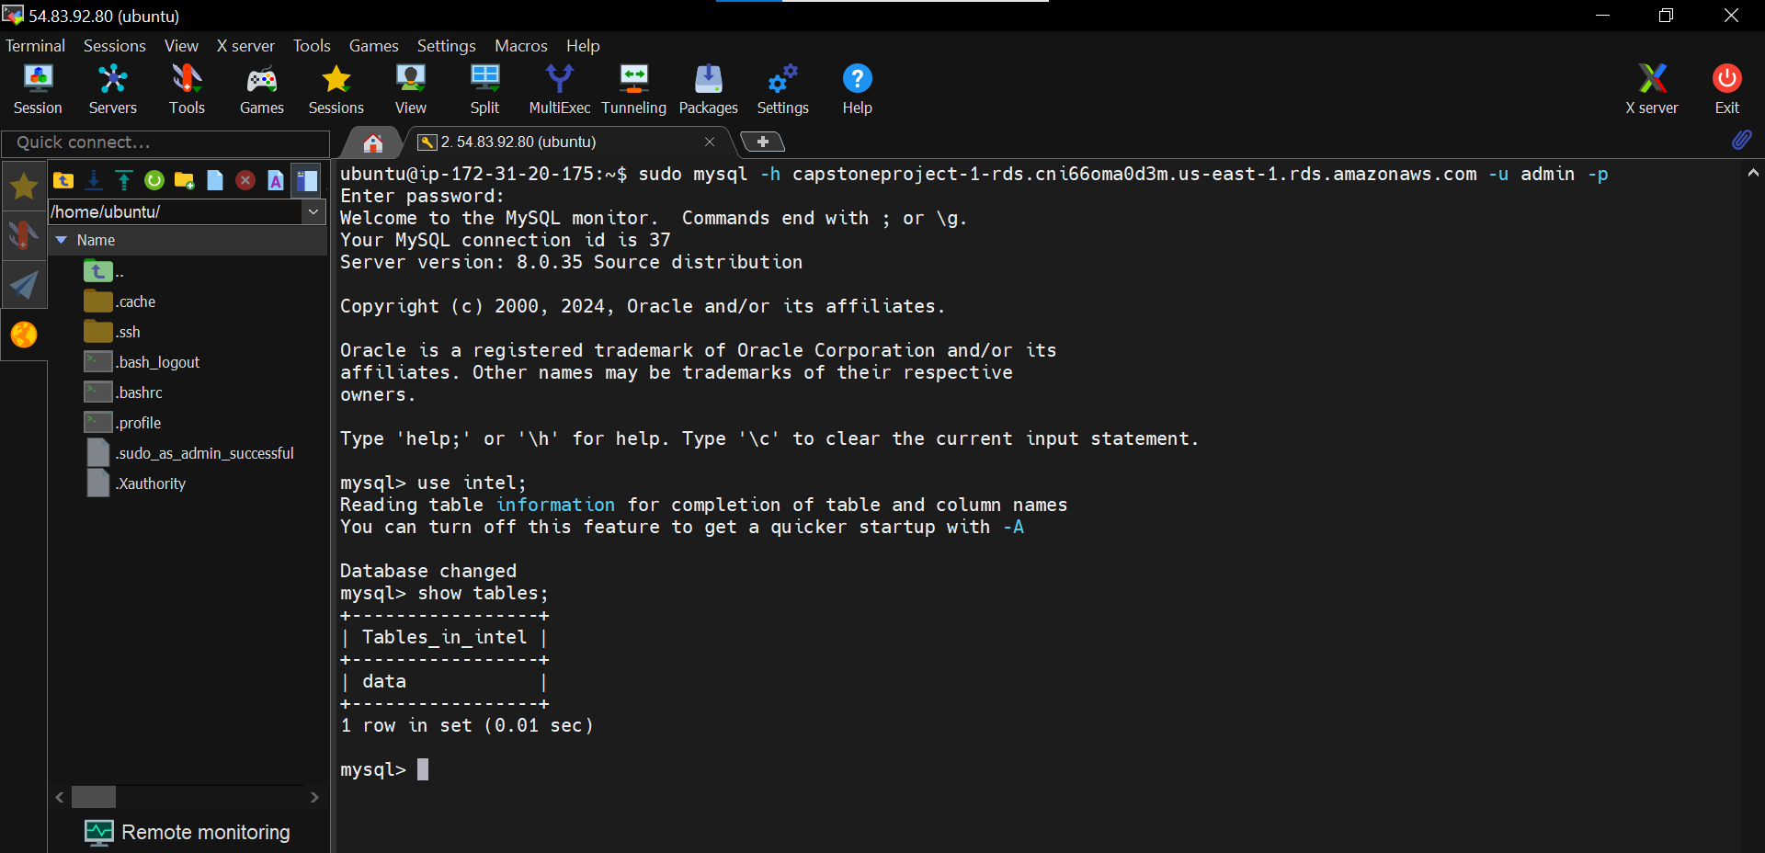

Use the command below to list all the new row entries in the database.

*select * from data;*

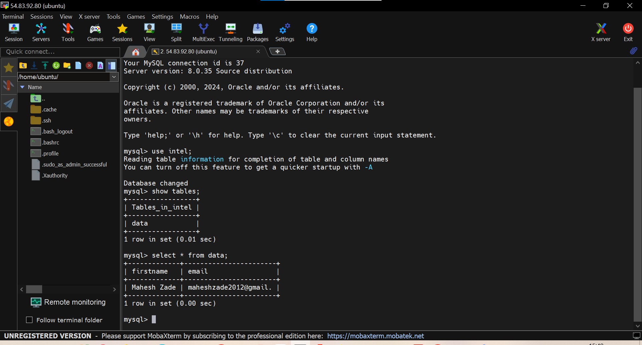

As you can see, the application is running successfully and we are able to store the

data from the application

Now, let's implement the Autoscaling for this application.

Choose the Instance and Click on **Create Image**.

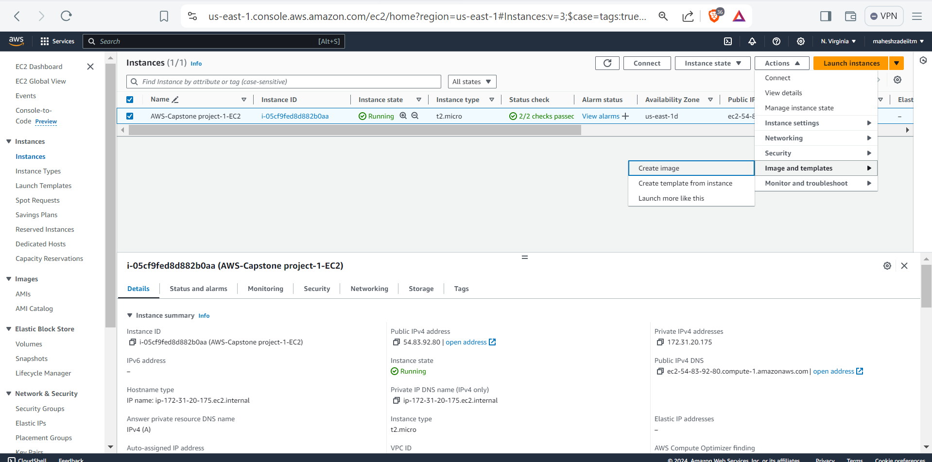

Provide a Name to the image and click on **Create**.

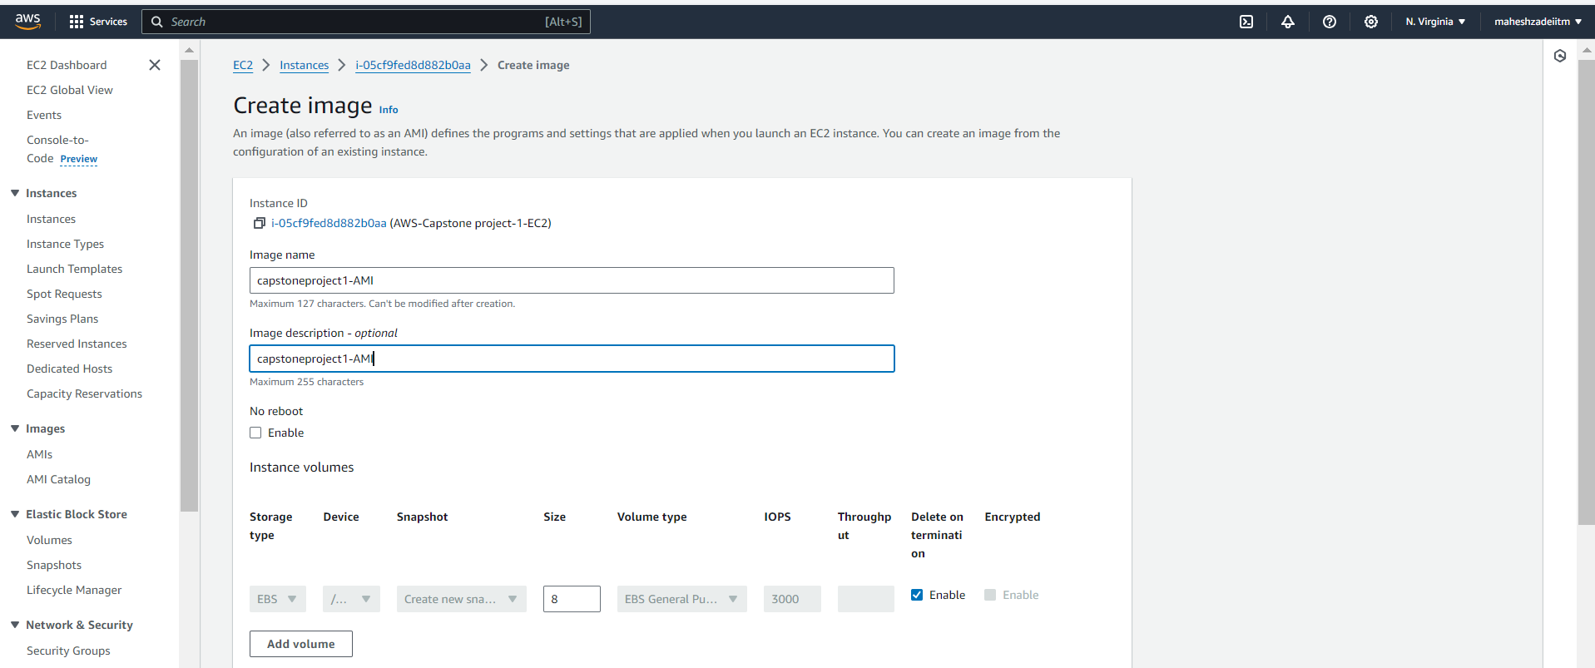

**Click on create image**

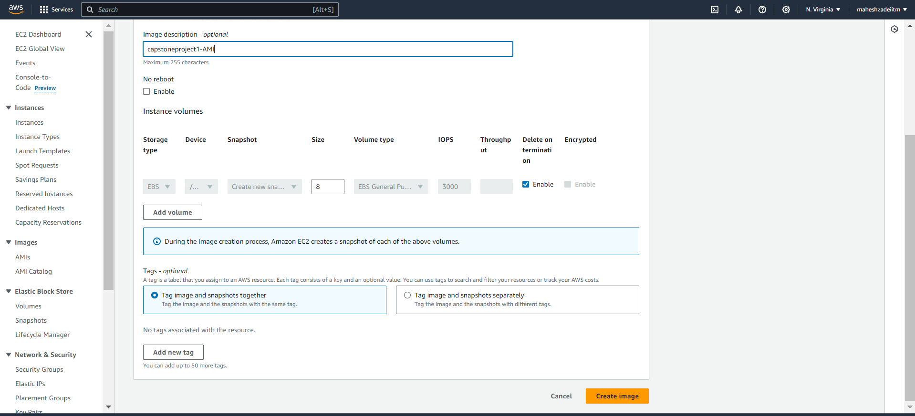

AMI is created.

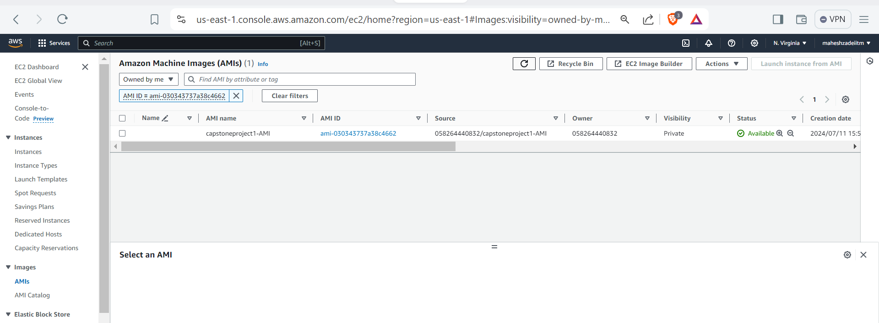

Now, we will use this AMI to create a Launch Template.

Select the EC2 Instance, Go to Actions, Images and Templates. Select Create

Template from Instance.

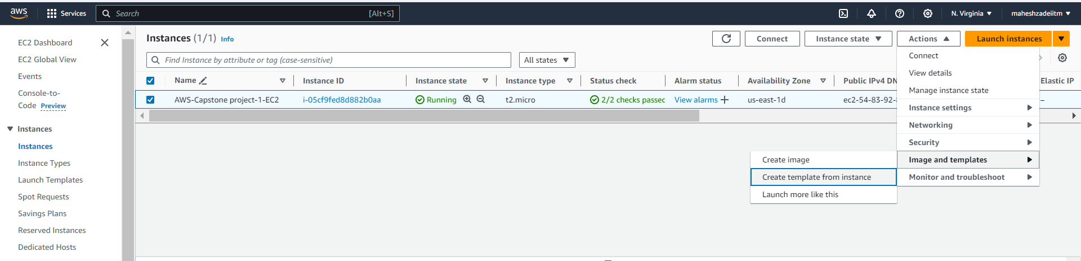

Provide a Name to the template and in version description, you can provide **main**.

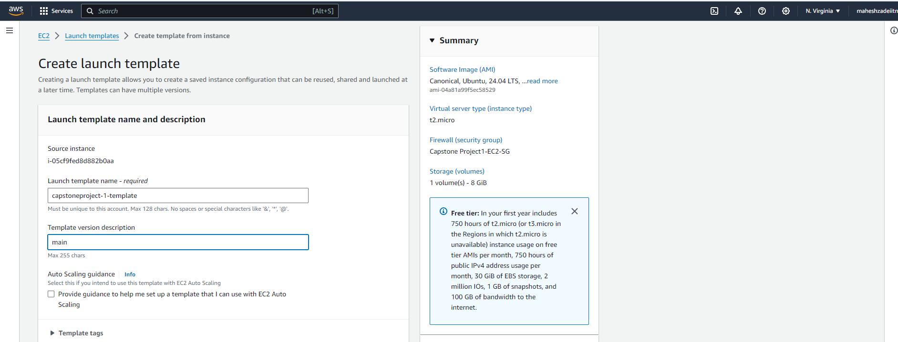

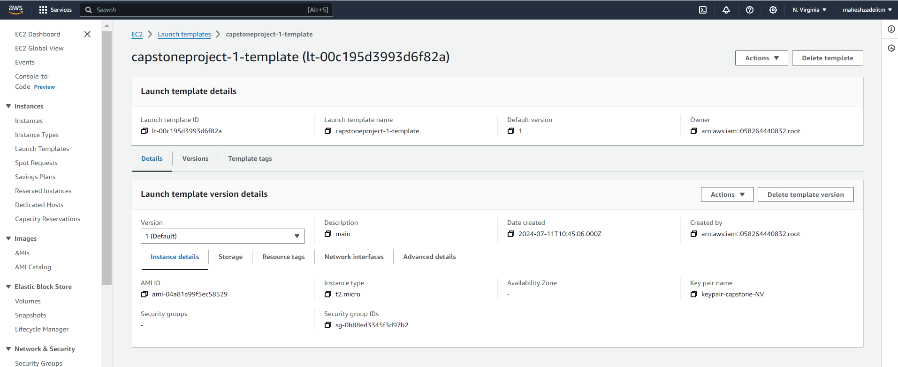

Now, When selecting AMI, go to **My AMI’s** and select the AMI that we created.

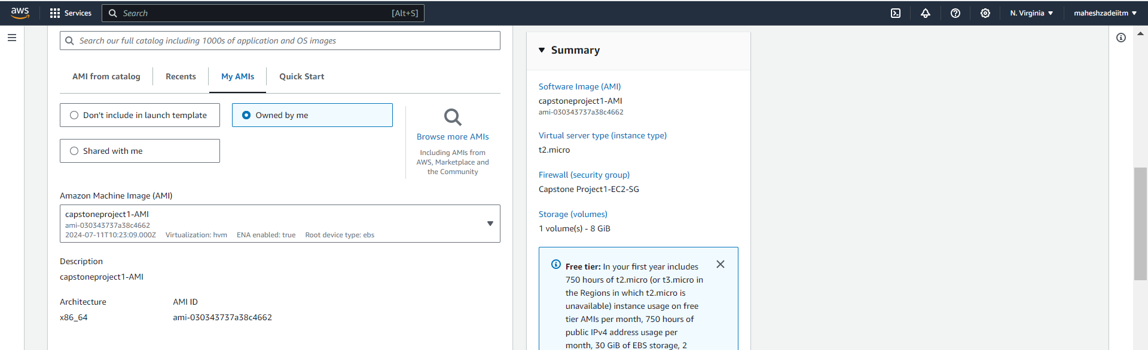

**Launch configuration** is created successfully.

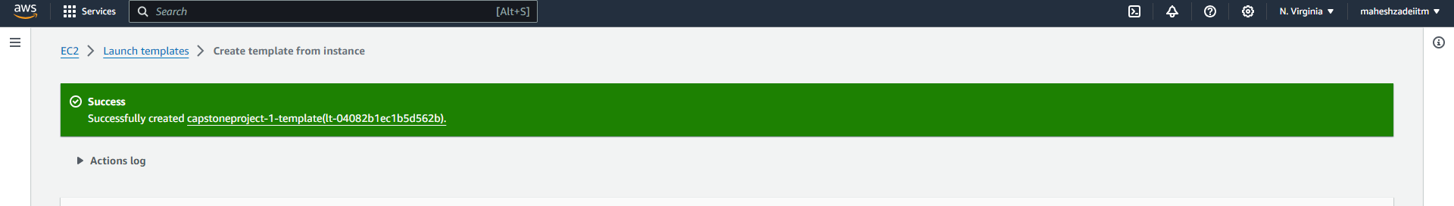

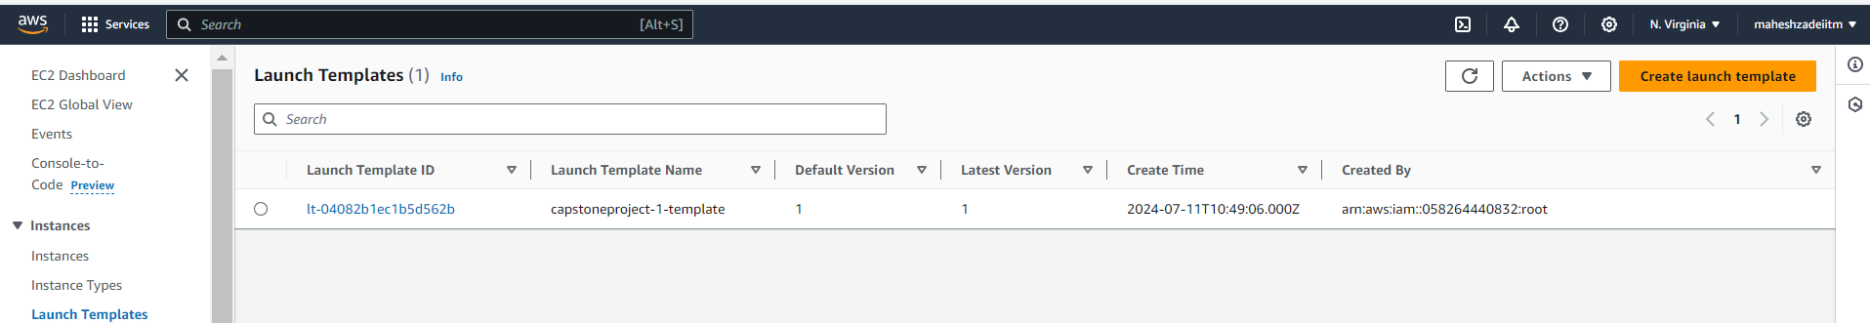

Now, let's create an Autoscaling Group using this Launch Template.

Provide a Name and select the Launch Template for Autoscaling group as shown

below.

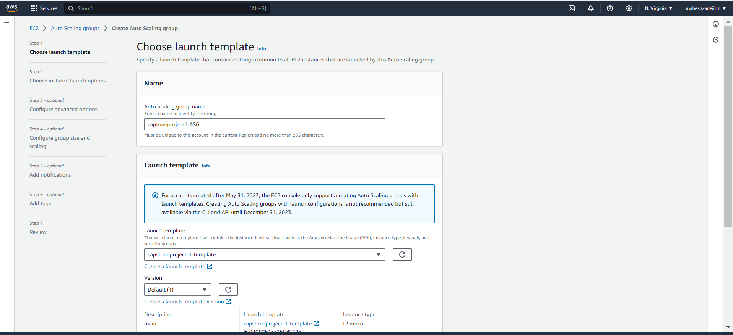

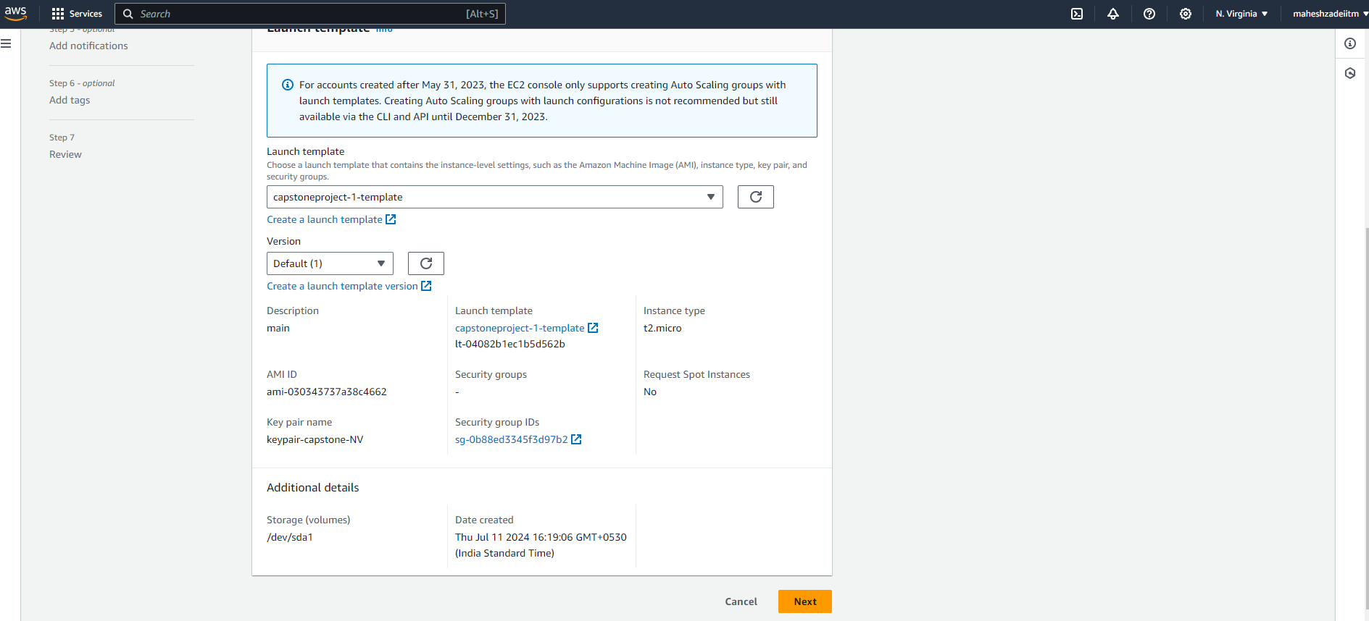

**Click next**

Select the **VPC** and **minimum of two availability zones** for high availability. In this

case we have selected all the availability zones available.

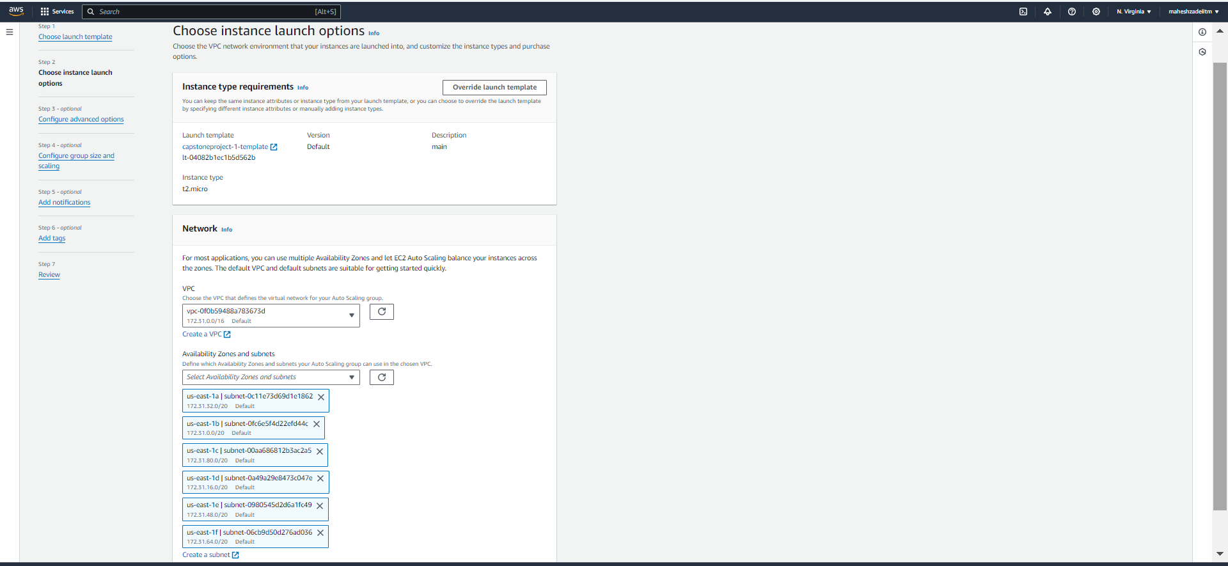

In load balancer, **Choose No Load Balancer**. Select the options as shown below.

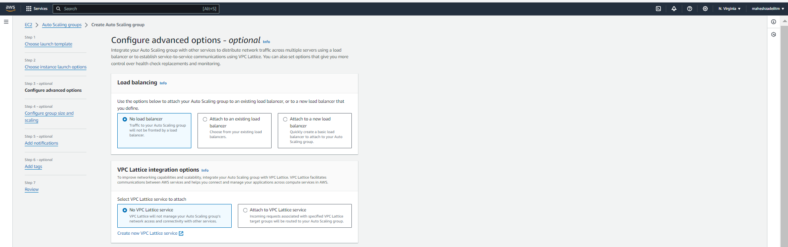

Choose the desired capacity in Group Size, in this case we have gone with **2,1 & 3**.

So, This autoscaling group will create minimum of two EC2 Instances to start with

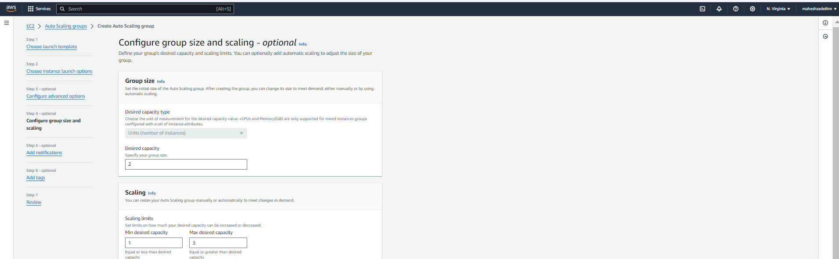

Notifications are optional, skip this and click on **Next**.

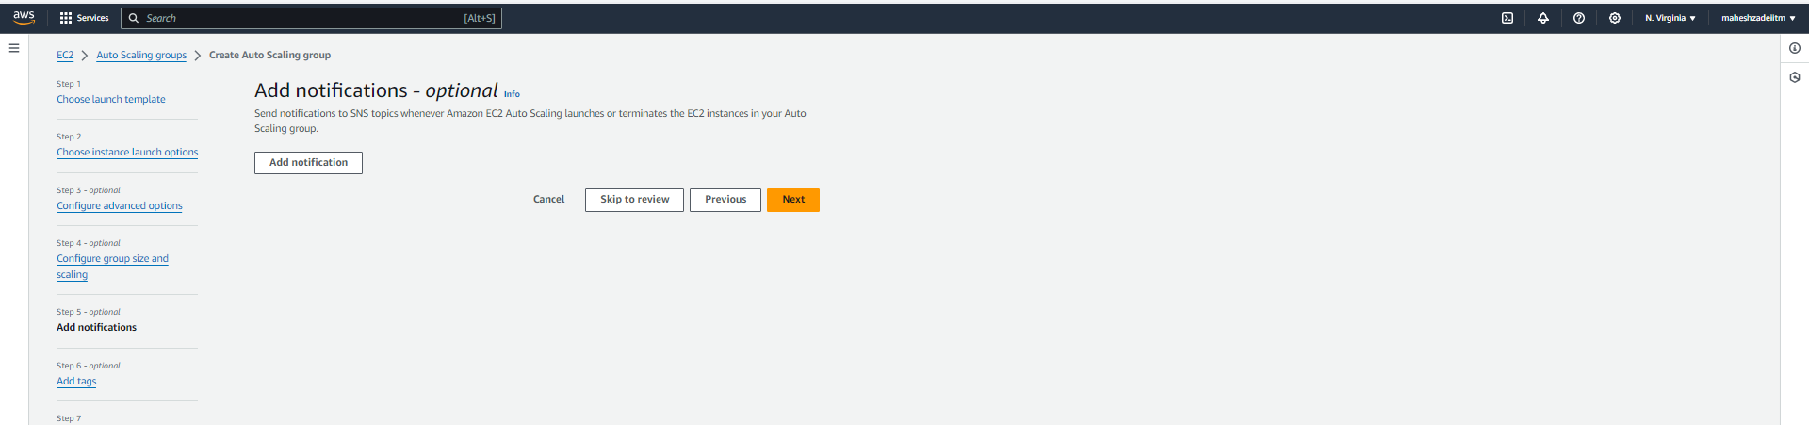

Tags are also optional, depending on whether you want to have tags on EC2

Instances created by Auto Scaling group.

Click on **Next**.

Review

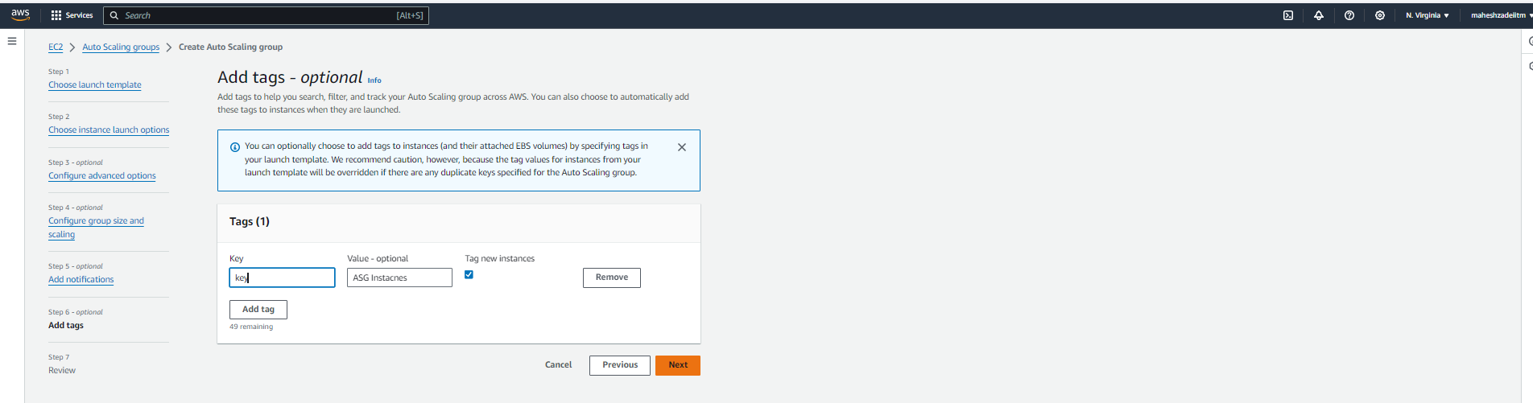

Review and Create Auto Scaling Group.

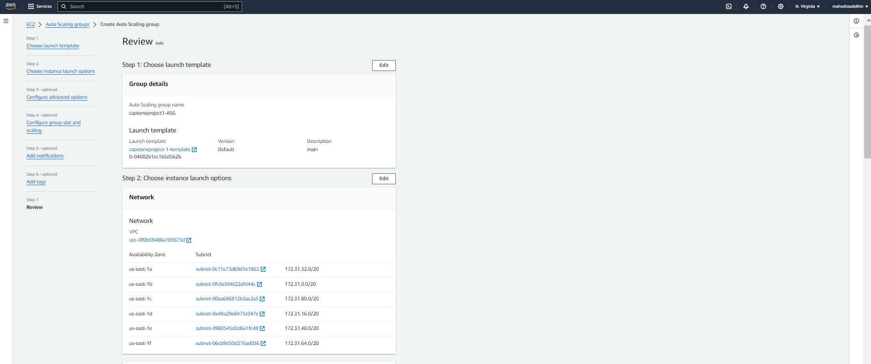

Click on Create Auto scaling Group

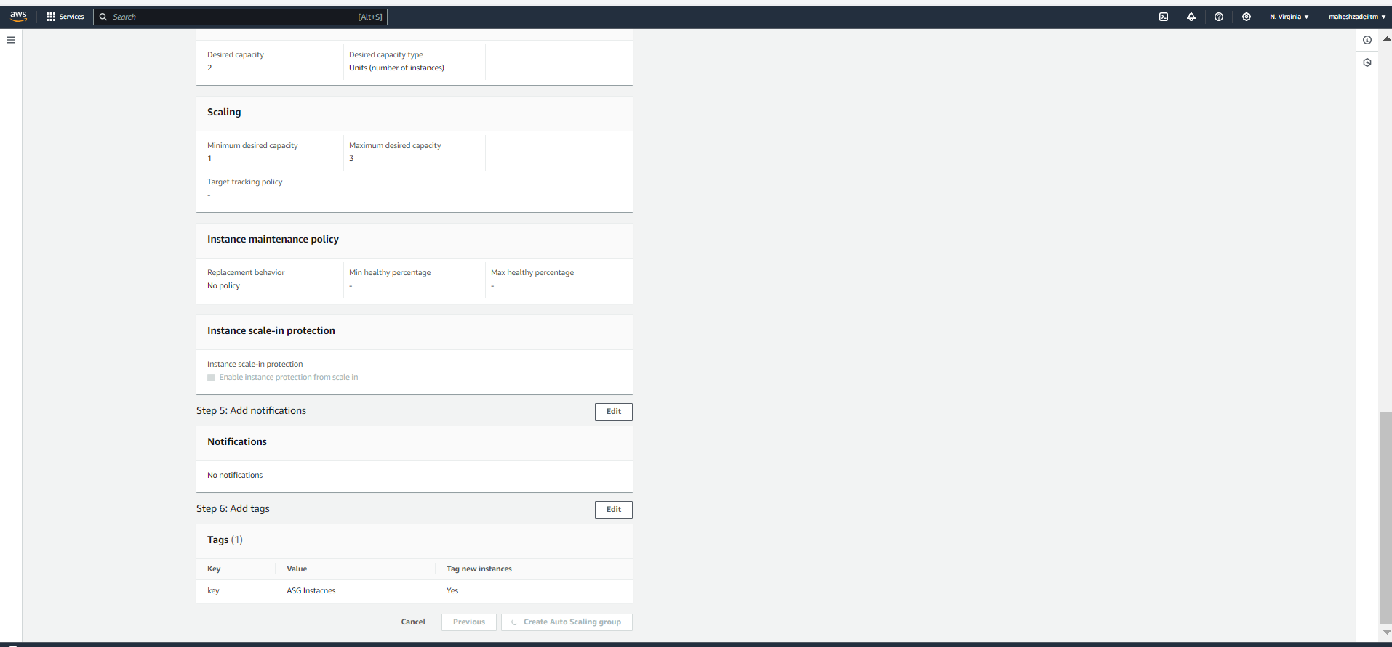

Auto scaling Group created

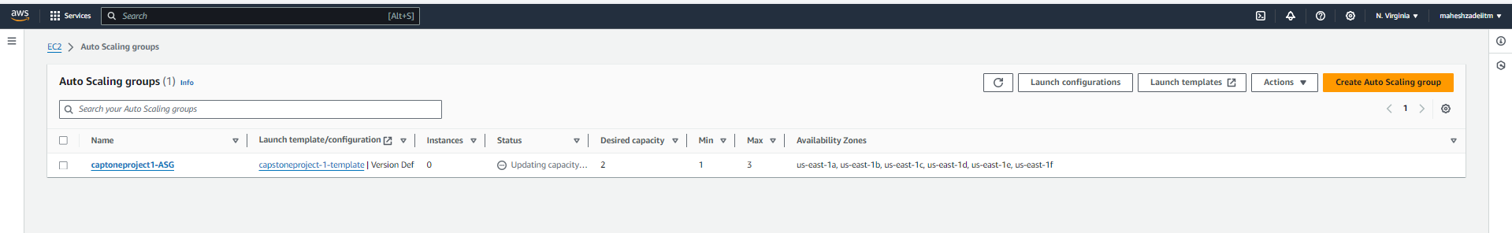

After creating Auto Scaling group, Go to Instances.

Here you should be able to see the newly created instances by Autoscaling Group.

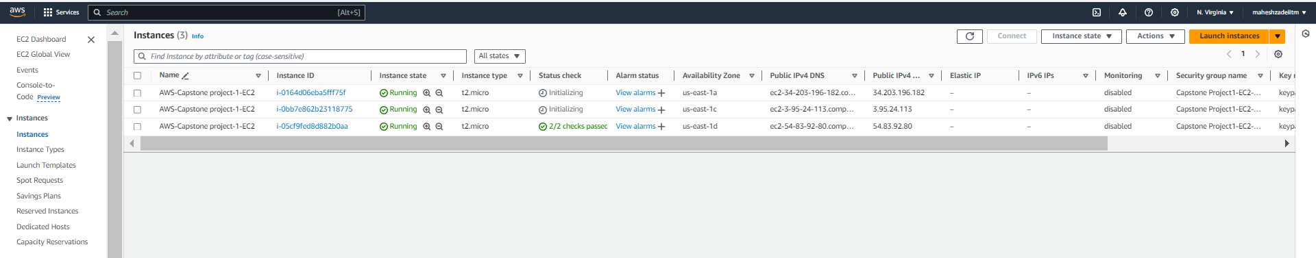

Copy and paste the public IP of any of the newly created servers in the browser and

you should be able to see the application already up and running inside them.

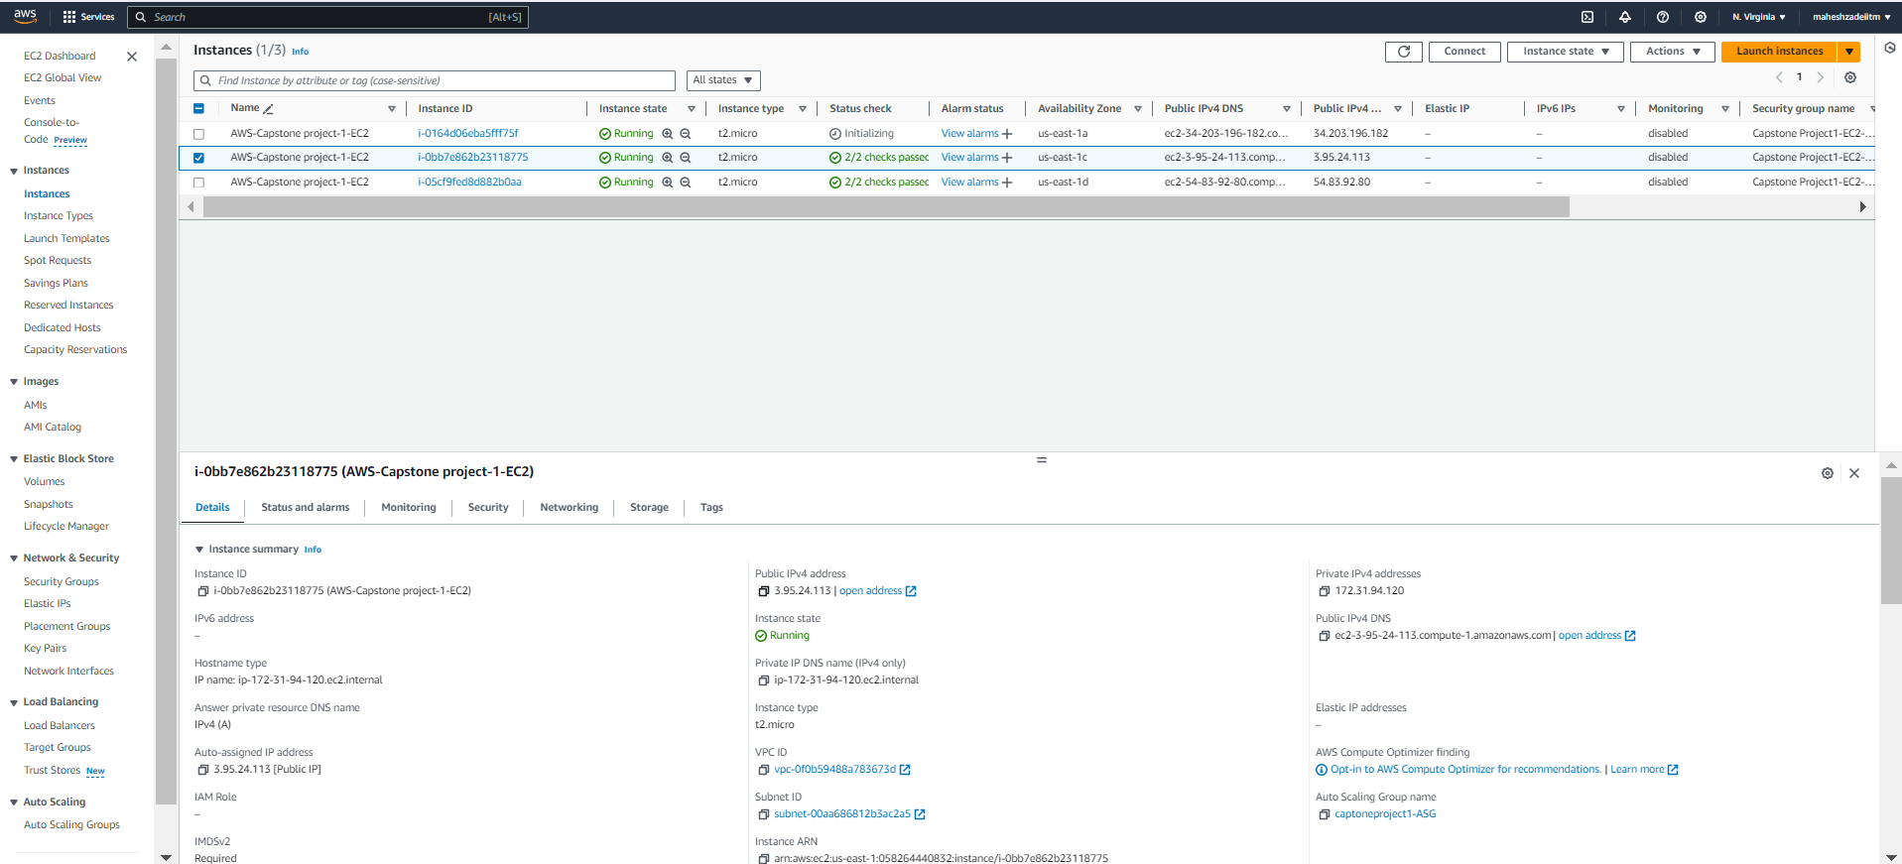

Copy the public IP and paste in the browser

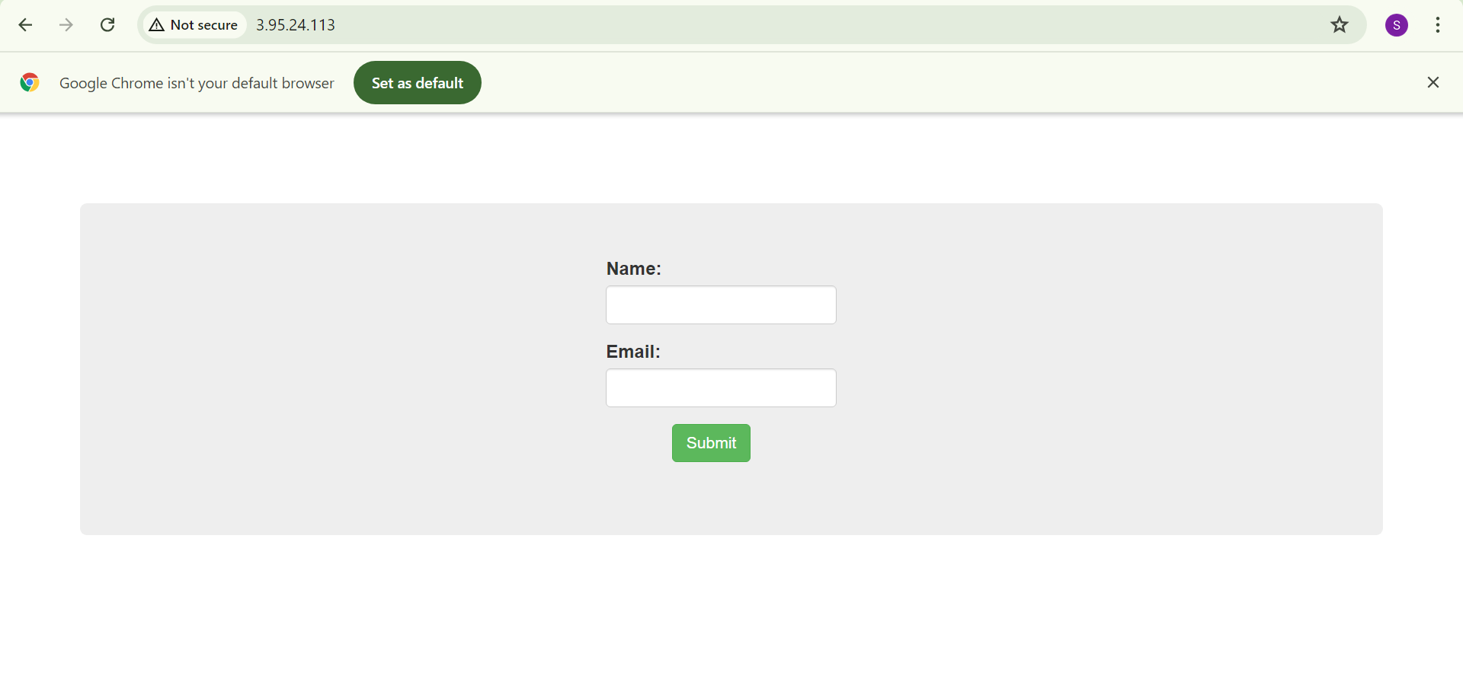

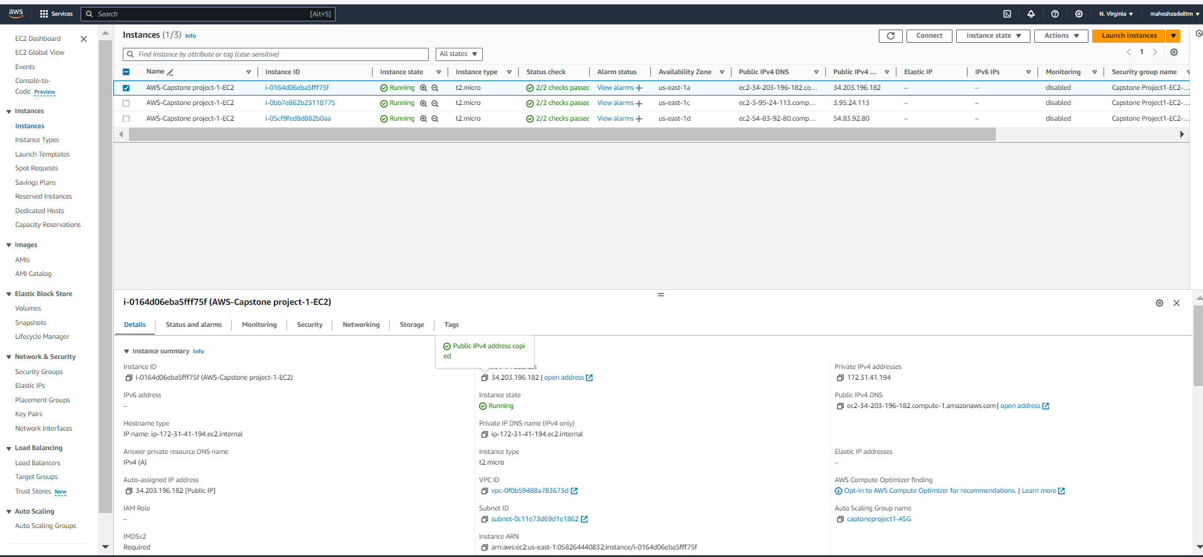

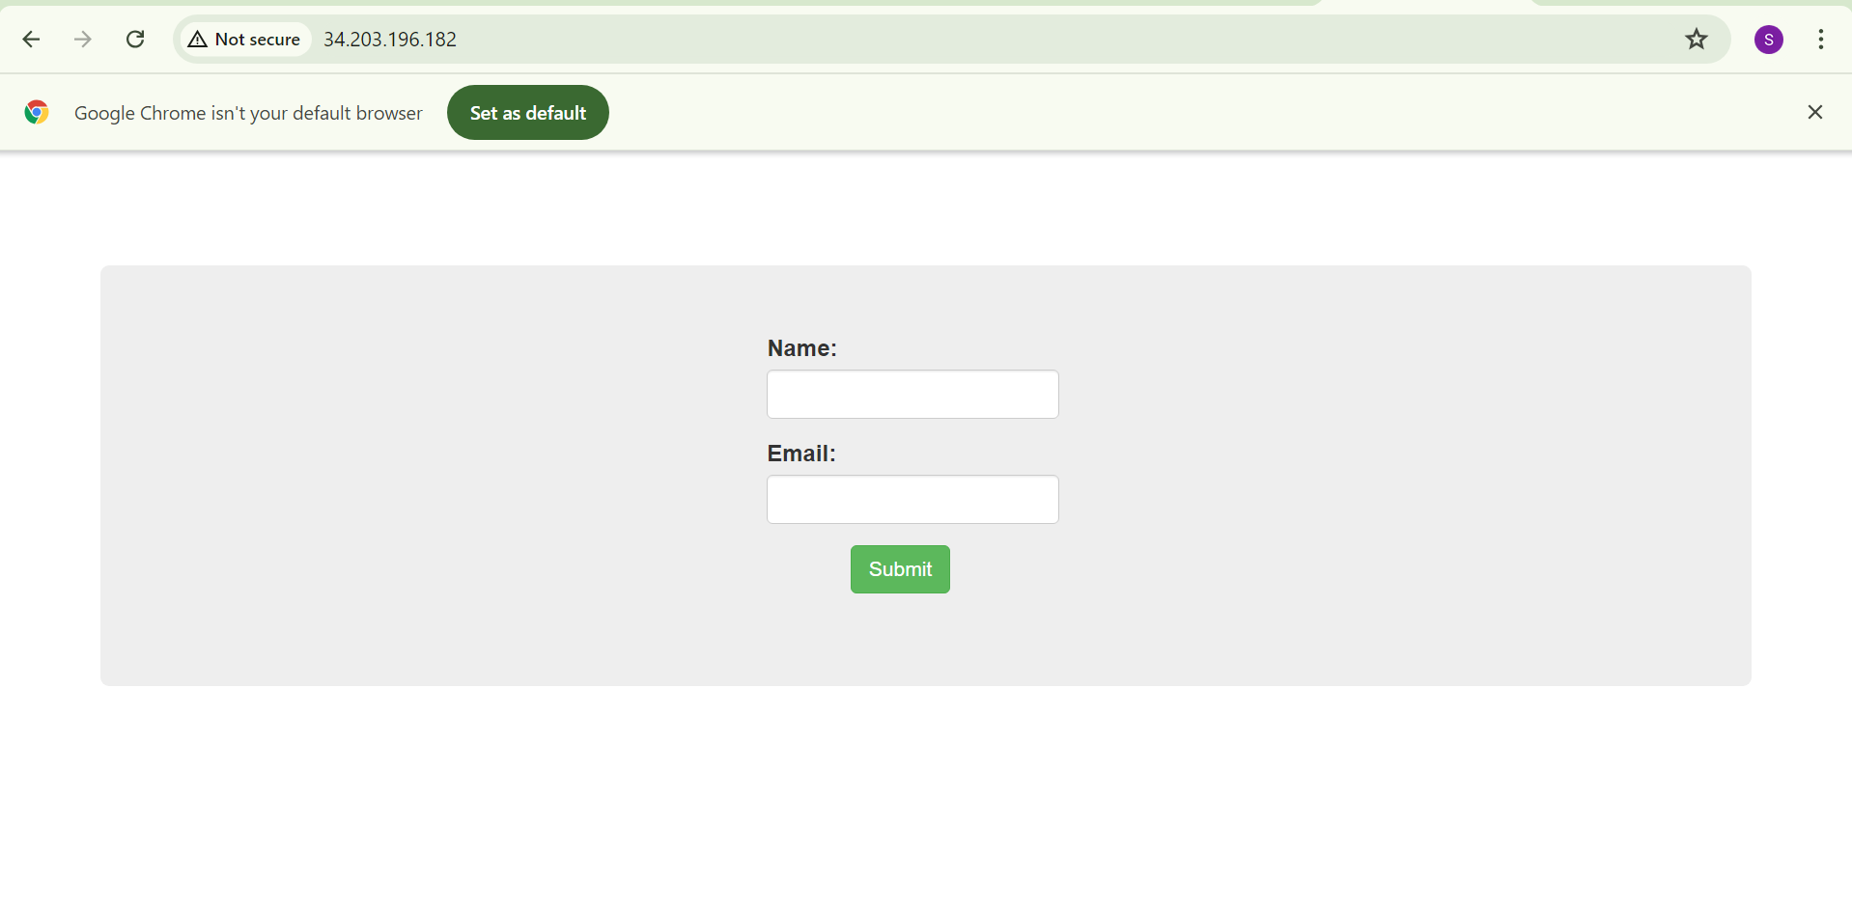

*Note: To clean up all the resources provisioned, terminate the RDS Instance first, then*

*Autoscaling Group, Launch Templates and AMI in the order followed up by the Initial EC2*

*Server we started with.*

This Completes the tutorial for **AWS Capstone project 1 - Deploying a Multi-tier Website**

**using EC2.**

**Thanks.**